Candidacy Presentation for

This template is NOT endorsed by ACEN nor is it required to use.
I have provided this for you to use to help you streamline the formatting of your document and to assure that you are including the information required for candidacy.

For questions or help in filling this out please contact sfield@winona.edu

***Narrative: The information needed in your narrative is bulleted in red throughout the document to assure you are addressing all of the items the readers will need to know.
Be sure to delete this portion once you have written to the criteria.

Double space your narrative

Table of Contents
Introduction 4
Table 1: Introduction Information 4
Figure 1: Higher Learning Commission Evidence 7
Figure 2: Minnesota State Authorization Evidence 8
Figure 3: Minnesota State Credential Grant Evidence 10
Figure 4: Minnesota Board of Nursing Evidence 13
Background of College Nursing Program 14
Standard 2 Faculty 15
Criteria 2.1 and 2.2 15
Table 2: Number of Faculty Academic Credentials 15
Table 3: Minnesota Licensure Requirement 16
Criteria 2.5 18
Table 4: Faculty to Student Ratios 19
Table 5: Faculty in Overload Past 3 Years with Rationale 19
Standard 4 Curriculum 21
The Curriculum Plan for each of the program options by Semester 22
Criteria 4.1 23
Table 6: Professional Nursing Standards 23
Criteria 4.2 24
Table 7: Example of SLO Organization Table 24
Criteria 4.8 26
Table 8: Program of Study by Semester 26
Table 9: Program Length Table 27
Criteria 4.9 29
Table 10: Clinical Sites Table 29
Table 11: Faculty and Student Survey Regarding Clinical Sites 29
Table 12: Clinical Sites and Contemporary Practice 31
Criteria 4.11 32
Standard 5 Resources 33
Criteria 5.1 33
Table 13: Nursing Program-Revenue Generated, Budget 33
Table 14: 3 Years Budget for Non-Personnel 34
Table 15: Budgets per Program and Number of Students for Fiscal Year 34
Table 16: Nursing to Institutional Budget 34
Table 17: Faculty Survey on Resources 34
Criteria 5.2 35
Table 18: Student Survey on Resources 35
Table 19: Faculty Survey on Resources 35
Table 20: Physical Resources 36
Criteria 5.3 37
Table 21: Student Service Survey on Resources 38
Table 22: Learning Resources Faculty Survey 38
Table 23: Resources and Technology 38
Standard 6 Outcomes 39
Table 24: Program Outcomes for Past 3 Years 39
Standard 6.1 41
Table 25: SLO Measurement 42
Appendix A: Faculty Profile Table 43
Faculty Qualifications and Experience 51
Appendix B: Faculty Scholarship Table and CVs 54
Appendix C: 2 Page Syllabi 55
Appendix D: SLO Organization Table 56
Appendix E: Clinical Evaluation Tools 57
Appendix F: HLC Program Length Requirements 58
Appendix G: Minnesota State Colleges Program Length 59
Appendix H: Faculty Contract for Hours/Credits 62
Appendix I: Systematic Evaluation Plan 64

Introduction

Table 1: Introduction Information
Name and Address of College

Name of the College CEO
Credentials
Job Title
Telephone
Fax
E-mail
Name of the institutional accrediting body | Higher Learning Commission: A Commission of the North Central Association of Colleges and Schools  30 North LaSalle Street  Suite 2400  Chicago, IL 60602-2502  P: 312-263-0456  www.ncahlc.org  Date of last review:  Last Outcome and Action Taken:  Next Review:  Supporting Evidence Figure 1: Higher Learning Commission documents
Name of state agency authorizing governing organization to provide postsecondary education program in the state – with supporting evidence | Minnesota State colleges and universities  30 E 7th St #350, St Paul, MN 55101  Phone:(651) 201-1800  http://www.mnscu.edu  Supporting Evidence Figure 2: Minnesota State authorization to provide postsecondary education
Name of state agency authorizing governing organization to grant the credential (degree, diploma and certificate) to the nursing program seeking accreditation – with supporting evidence) | Minnesota State colleges and universities  30 E 7th St #350, St Paul, MN 55101  Phone:(651) 201-1800  http://www.mnscu.edu  Supporting Evidence Figure 3: Minnesota State credential granting
Name and address of the nursing education unit
Name of the nurse administrator
Credentials
Job Title
Telephone
Fax
email
Name of the state regulator agency for nursing  (date of last review and action taken – supporting documentation  Next Review | Minnesota Board of Nursing  2829 University Avenue SE # 200  Minneapolis, MN 55414-3253  Phone: 612-317-3000  mn.gov/health-licensing-boards/nursing/  Supporting Evidence Figure 4: Minnesota Board of Nursing
The number of full- and part-time faculty at each location  (Remove lines which do not relate to your program)  FT: Full-time  PT: part-time | Number of FT nursing faculty teaching in AD Program only:  Number of PT nursing faculty teaching in AD Program only:  Number of FT nursing faculty teaching in PN Program only:  Number of PT nursing faculty teaching in PN Program only:  Number of FT Nursing faculty teaching in Both programs:  Number of PT Nursing faculty teaching in Both programs:  Number of faculty by location:  Location 1:  FT:  PT:  Both programs:  Location 2:  FT:  PT:  Both Programs:
Total number of full- and part-time students currently enrolled in each program and/or option at each location if applicable.  (Remove lines which do not relate to your program)
  Total enrollment:
   |  | Total enrollment:
  Full-time:
  [Insert Option]: |  | Full-time:
  [Insert Option |  | [Insert Option]:
   |  | [Insert Option
  Part-time:
  [Insert Option]: |  | Part-time:
  [Insert Option]: |  | [Insert Option]:
   |  | [Insert Option]:
Length of program in credits/hours as well as academic terms for all program options.
  Name of Program Option:
  Method of Delivery: | - Face- to face ☐ Hybrid  - Distance Education
  Percentage of Nursing Credits Delivered by Distance Education: | ☐ 0% ☐ 1–24% ☐ 25–49%  50–100%
  Student Enrollment Status: | - Full-time ☐ Part-time
  Academic Term Type: | - Semesters
  Length of Academic Term (in weeks): | 16 weeks
  Length of Time/Required Number of Academic Terms:
  Total Number of Credits:
  Nursing Credits:
  General Education Credits
  Name of Program Option:
  Method of Delivery: | - Face- to face ☐ Hybrid  - Distance Education
  Percentage of Nursing Credits Delivered by Distance Education: | ☐ 0% ☐ 1–24% ☐ 25–49%  50–100%
  Student Enrollment Status: | - Full-time ☐ Part-time
  Academic Term Type: | - Semesters
  Length of Academic Term (in weeks): | 16 weeks
  Length of Time/Required Number of Academic Terms:
  Total Number of Credits:
  Nursing Credits:
  General Education Credits

Figure 1: Higher Learning Commission Evidence

https://www.hlcommission.org/Directory-of-HLC-Institutions.html

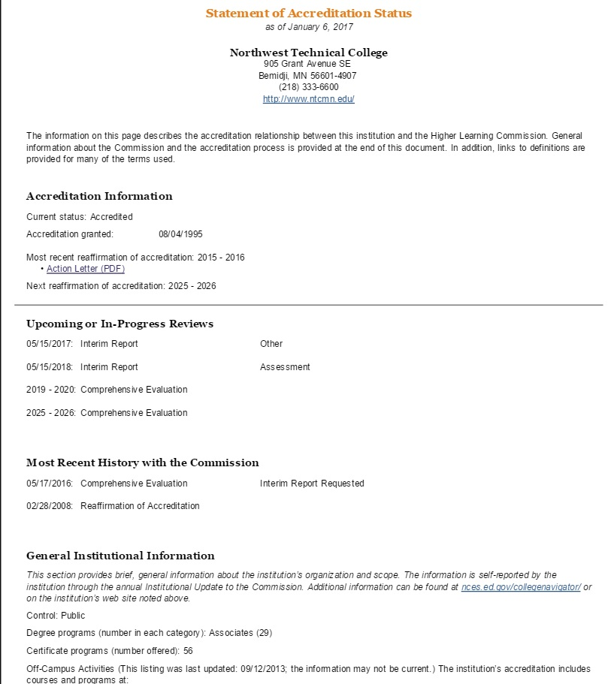

Figure 2: Minnesota State Authorization Evidence

Figure 3: Minnesota State Credential Grant Evidence

MINNESOTA STATUTES 2016
136F.06 POWERS AND DUTIES.
Subdivision 1. General authority. The board shall possess all powers necessary to govern the state colleges and universities and all related property. Those powers shall include, but are not limited to, those enumerated in this section. The board shall prescribe conditions of admission, set tuition and fees, approve programs of study and requirements for completion of programs, approve the awarding of appropriate certificates, diplomas, and degrees, enter into contracts and other agreements, and adopt suitable policies for the institutions it governs. To the extent practicable in protecting statewide interests, the board shall provide autonomy to the campuses while holding them accountable for their decisions. Sections 14.01 to
14.47 do not apply to policies and procedures of the board.
Subd. 2. Governance authority. The board shall have the authority needed to operate and govern the state colleges and universities unless otherwise directed or prohibited by law. The board is responsible for its operations and necessary decisions unless these are specifically delegated by law to a state department or agency.
Subd. 3. Office location. Notwithstanding chapter 16B, the board may select the location for its central office.
Subd. 4. Workforce focus. The board must identify colleges offering flexible academic programs that accommodate the needs of laid-off workers and assist its other institutions in determining whether to offer similar programs. Colleges must increase the number of certificate programs available to meet the needs of unemployed Minnesotans.
Subd. 5. Streamlined Minnesota State Colleges and Universities system office. Notwithstanding any law or policy to the contrary, the board shall streamline services provided through the system's central service office to reduce expenditures, better target the use of state resources, and provide services at the most appropriate and efficient level so as not to duplicate any services provided at the institutional level. These actions must be implemented so as to achieve budgetary savings and efficiencies in delivery of services and the accomplishment of the academic mission. The board must revise any board policies in a way that is consistent with the requirements of this section.
History: 1991 c 356 art 9 s 5; 1Sp1993 c 2 art 9 s 4; 1994 c 572 s 2; 1995 c 212 art 4 s 10-12,64; 1996
c 398 s 33,34; 2010 c 347 art 1 s 21; 2010 c 364 s 30; 2014 c 149 s 74

Copyright © 2016 by the Revisor of Statutes, State of Minnesota. All Rights Reserved.

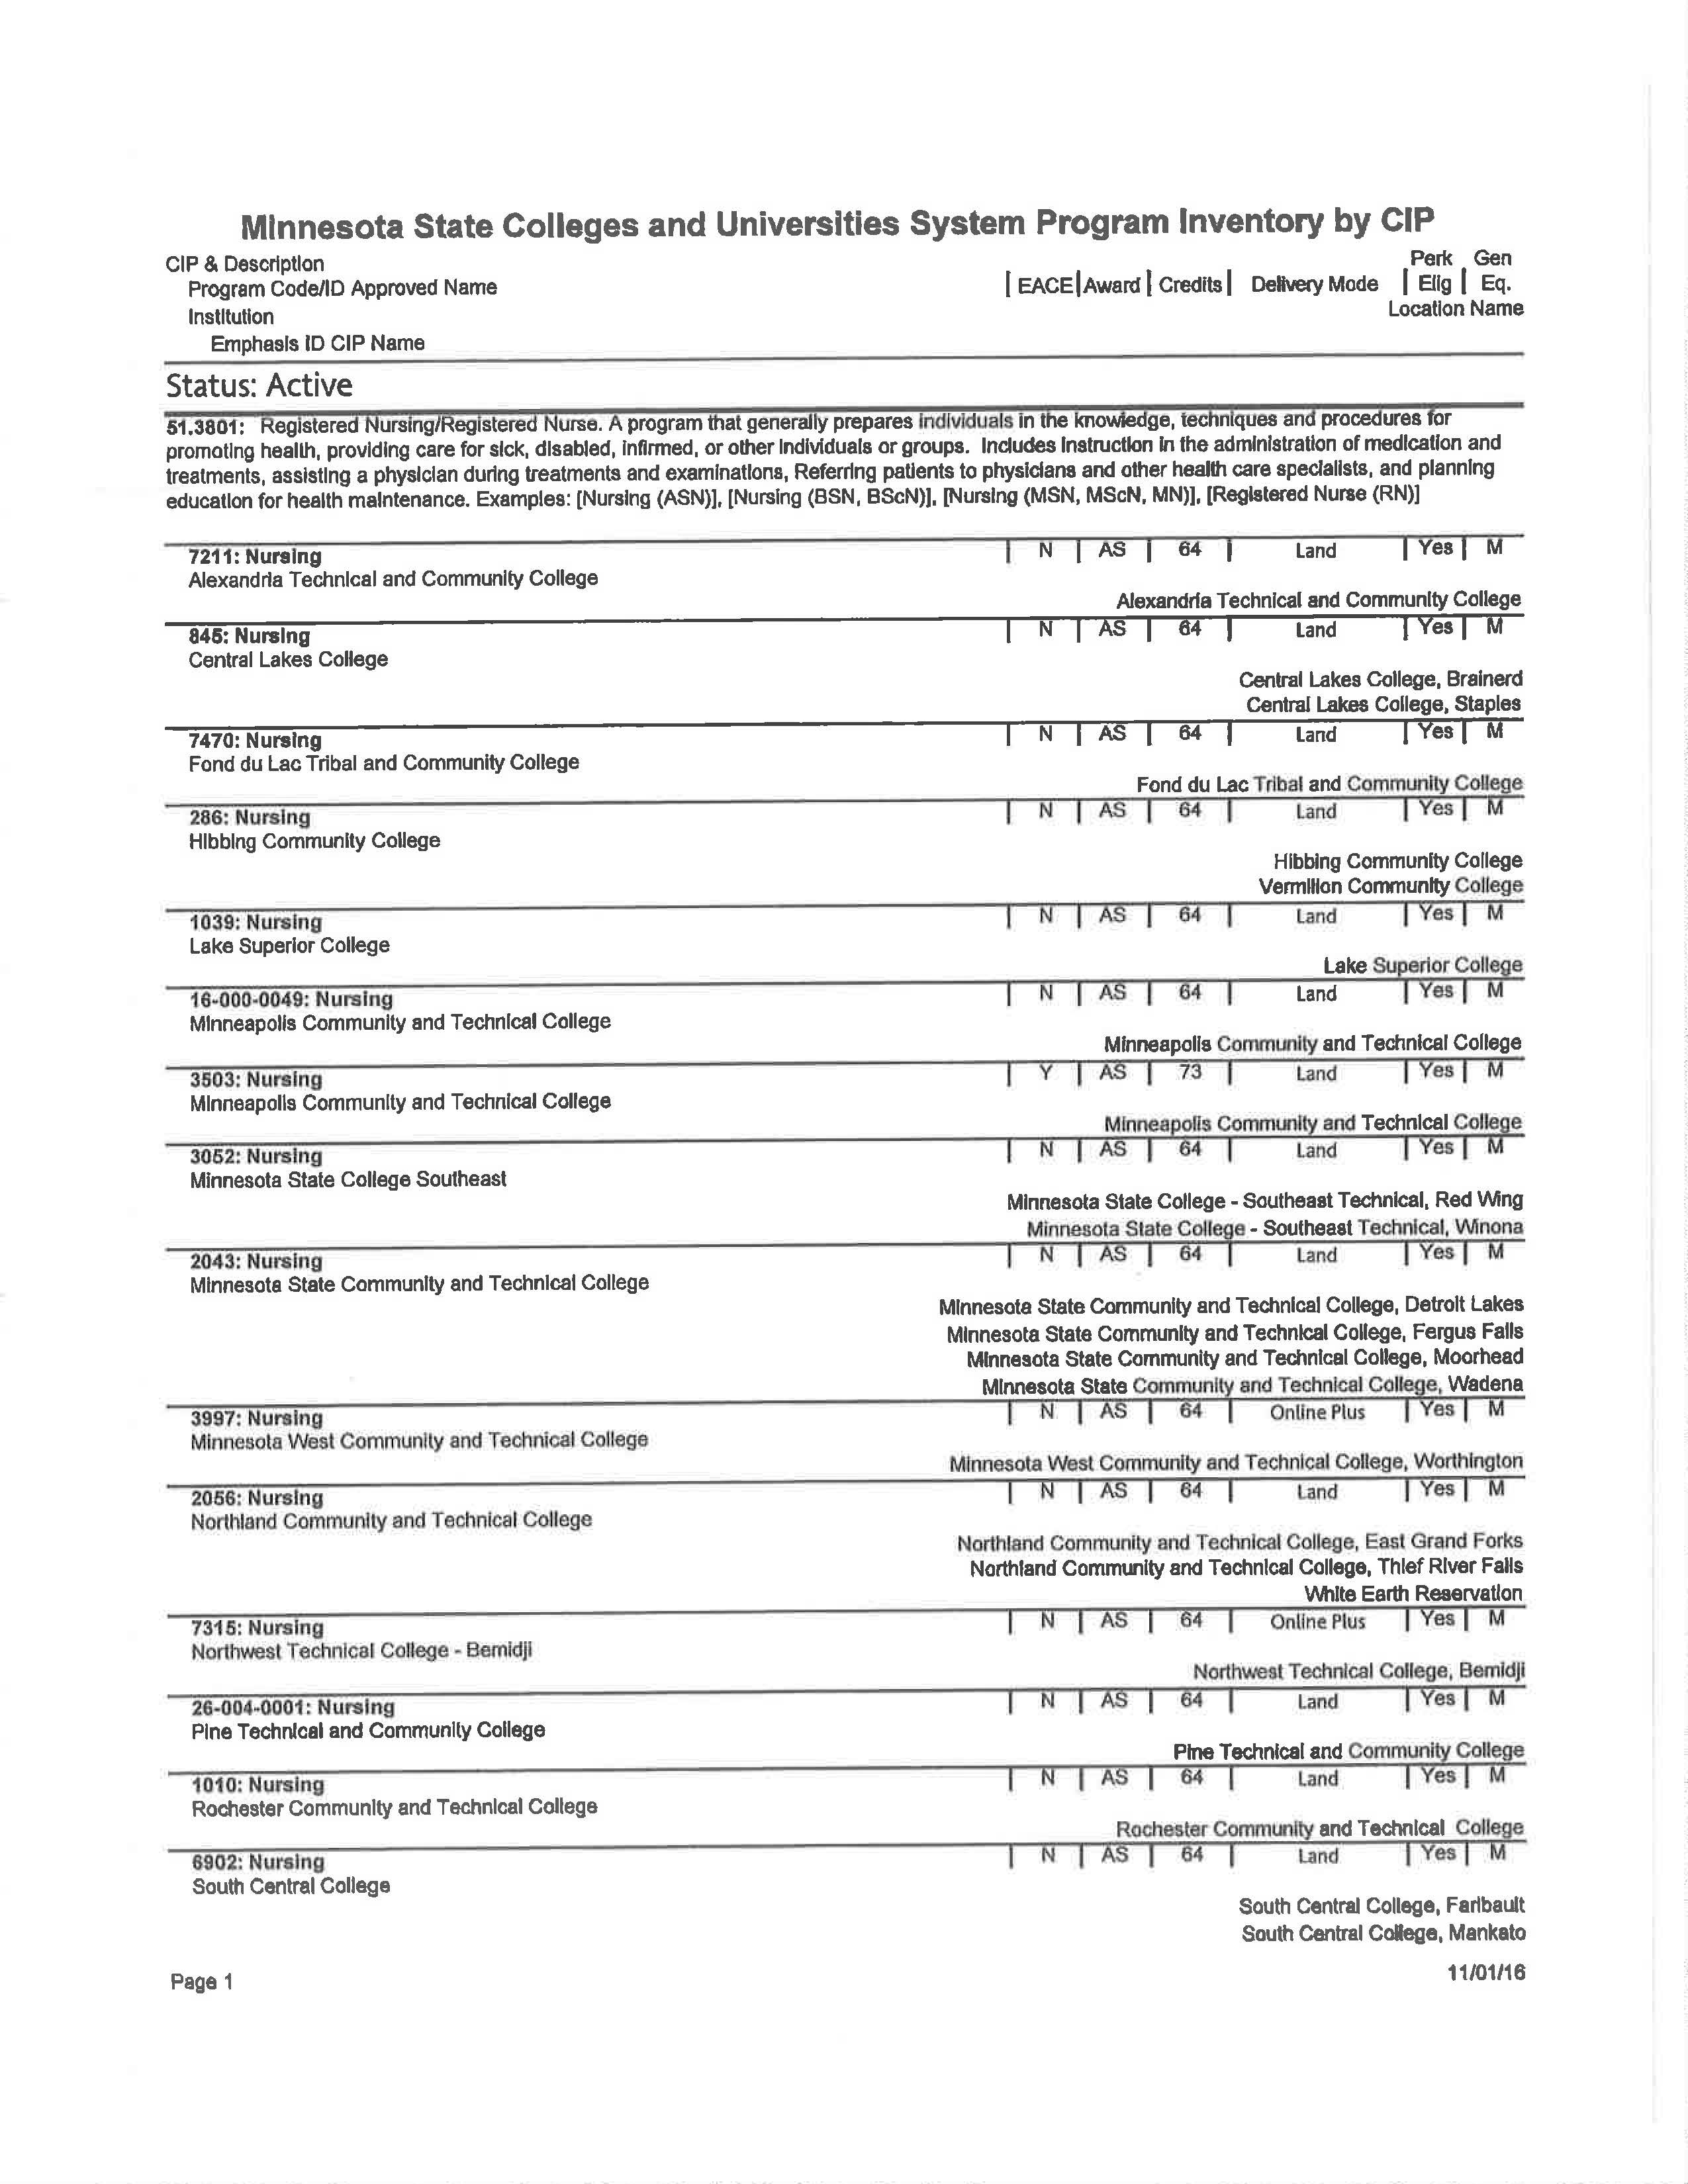
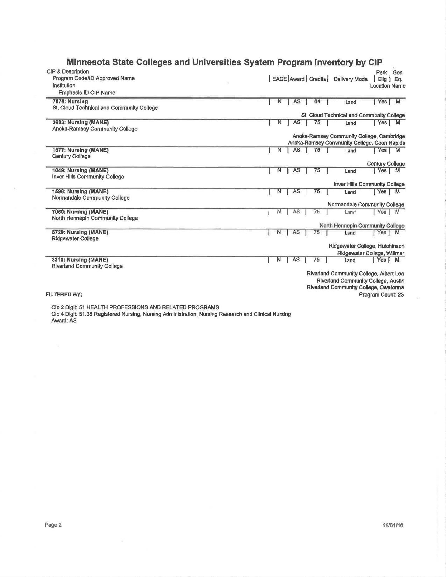

Figure 4: Minnesota Board of Nursing Evidence

Background of College Nursing Program
Narrative:
- Explain Minnesota State’s organization, and then explain how your college fits in this. Then explain your nursing program (brief history and programs).
- Take a look at the example of Normandale’s self-study introduction. It gives you a good picture of their program. That’s what the readers will want, they need to see how your program fits into the rest of the state and college.
- The part that I did not put in from Normandale was an overview of their curriculum. Tell your story here, briefly and succinctly.
- If the nursing program has multiple locations, the introduction to the Candidacy Presentation must provide a brief narrative regarding how the program functions as a single nursing program with the oversight of the identified nurse administrator and how faculty members work together as a single faculty.

Standard 2 Faculty

Criteria 2.1 and 2.2
2.1 Full-time nursing faculty hold educational qualifications and experience as required by the governing organization, the state, and the governing organization's accrediting agency, and are qualified to teach the assigning nursing courses.
2.2 Part-time nursing faculty hold educational qualifications and experience as required by the governing organization, the state, and the governing organization's accrediting agency, and are qualified to teach the assigned nursing courses.

*** Narrative
- Describe Table 2 below which is a table that the site reviewers use and gives a quick snap shot of your program.
- Delete the rows on table 2 that do not represent your program.
- Begin Narrative after each bolded section.

Number of Faculty Academic Credentials:

Table 2: Number of Faculty Academic Credentials
Nursing Faculty Academic Credentials – (Highest Degree Only) –PN Program Only
Number of Faculty | Doctoral |  |  |  |  | Master’s |  |  | Baccalaureate |  |  | Associate
Number of Faculty | Nursing |  |  | Non-nursing |  | Nursing |  | Non-nursing | Nursing |  | Non-nursing | Nursing | Non-nursing
Full-Time |  |  |  | 0 |  |  |  | 0 |  |  | 0 |  | 0
Part-Time |  |  |  | 0 |  |  |  | 0 |  |  | 0 |  | 0
Nursing Faculty Academic Credentials – (Highest Degree Only) – Associate Degree Program Only
Number of Faculty | Doctoral |  |  |  |  | Master’s |  |  | Baccalaureate |  |  | Associate
Number of Faculty | Nursing |  |  | Non- nursing |  | Nursing |  | Non- nursing | Nursing |  | Non-Nursing | Nursing | Non- nursing
Full-Time |  |  |  | 0 |  |  |  | 0 |  |  | 0 |  | 0
Part-Time |  |  |  | 0 |  |  |  | 0 |  |  | 0 |  | 0
Nursing Faculty Academic Credentials – (Highest Degree Only) –Shared AD and PN Program Only
Number of Faculty |  | Doctoral |  |  | Master’s |  |  |  | Baccalaureate |  |  | Associate
 |  | Nursing | Non- nursing |  | Nursing |  | Non- nursing |  | Nursing | Non-Nursing |  | Nursing | Non- nursing
Full-Time |  |  | 0 |  |  |  | 0 |  |  | 0 |  |  | 0
Part-Time |  |  | 0 |  |  |  | 0 |  |  | 0 |  |  | 0

**Narrative:
- Explain what the readers will find on the Faculty Profile and that it is in Appendix A.
- This is a quick description of Appendix A: The Faculty Profile table includes the academic and experiential qualifications, including all degrees and experience in education and clinical areas, areas of teaching responsibilities and non-teaching responsibilities.
- Address in the narrative whether your faculty meet the following requirements which are found on Appendix A- Page 1 of the Faculty Profile:
  - MN State requirements
  - HLC requirements
  - Board of Nursing requirements
- Begin your narrative after each bolded title below

Faculty Profile:

Minnesota State Requirements:
Higher Learning Commission Requirements:
Minnesota Board of Nursing Requirements:

Table 3: Minnesota Licensure Requirement
Name | MN License # | Expiration Date

Hyperlink to Faculty Profile: Appendix A
**Narrative for your program:
- You might want to use the ACEN glossary definition to start this section: Scholarship is defined by the ACEN glossary (p. 14) as activities that facilitate the enhancement of a nursing faculty member’s expertise and support the achievement of the end of program student learning outcomes and program outcomes. These include, but are not limited to, application of knowledge, teaching, service, practice and research.
- Write about your programs scholarship. It might be primarily in teaching.
- You should describe what they will find in Appendix B example:
The Faculty Scholarship Table displays the scholarly activities and maintenance of evidence based teaching practice and expertise in teaching areas along with the experience of the faculty in the nursing program and in nursing education.
- Begin your narrative after each bolded title below:
Faculty Scholarship Definition and Examples:
Hyperlink to Faculty Scholarship Table: Appendix B

Criteria 2.5
2.5 The number of full-time faculty is sufficient to ensure that the end-of-program student learning outcomes and program outcomes are achieved.
** Narrative:
- You need to explain the faculty contract for how your work load is determined. Take a look at how Normandale explained it.
- I have put the information for the former MCCFA and UTCE faculty in Appendix H.
  - Give a brief summary to make it easy to understand and refer to the portions in Appendix H that pertain to your faculty. Remove from Appendix H, any portion that you do not use (MCCFA or UTCE, if you are not using a portion of it and do not remove it, this will confuse the readers). Use only the portion of the contract that pertains to your faculty.
- Begin your narrative after each bolded title below:

Faculty Contract:
Hyper-link to MSCF Contract
MSCF Contract for Credits/Contact Hours Appendix H

**Narrative:
- Explain how your faculty function. Look at the example from Normandale.
- One piece of evidence that you have enough full time faculty is your faculty ratio of full time faculty to the number of students.
  - To determine your faculty to student ratio, take the
    - # of FULL TIME faculty/the number of students you have.
    - (The ideal is less than 1:20 but 1:20 to 1:25 is pretty average. If over 1:25 tell your story, are you rural and you need to have multiple Part Time instructors to fill positions distantly?
    - Whatever reason you have for this, tell your story).
  - Then refer the readers to table 4 faculty to student ratios for courses. Explain what the table shows.
- Begin your narrative after each bolded title below:

Full Time Faculty:

Table 4: Faculty to Student Ratios
Course Number and Name | Credits  Theory/Lab/clinical | Faculty to students  Theory | Faculty to students  Lab | Faculty to students  Clinical/Simulation

**Narrative:
- Talk about Table 5 and whether you have had to use overload or not. This will give evidence as well as to whether or not you have enough full time faculty.
- Begin your narrative after each bolded title below:

Faculty Overload:

Table 5: Faculty in Overload Past 3 Years with Rationale

Faculty in Overload | Overload | Overload | Overload
(List only those in overload) | School Year: | School Year: | School Year:
Rationale for School Year overload for:
Rationale for School Year overload for:
Rationale for School Year overload for:

**Narrative:
- Talk about your faculty as a whole and then refer readers to Appendix A Faculty Profile for specific faculty committee work and service.
- Talk about the responsibilities as a faculty member, faculty committee work for the nursing program, for the college, office hours, do you advise?
- Do you have a nursing club you advise?
- What other responsibilities are the faculty a part of?
- Do you have staff meetings? How often?
- Do you have accreditation meetings? How often?
- Are faculty assigned accreditation standards?
- How is the work for accreditation divided?
- What about advisory boards, do faculty go to those?
- Do you do any service to the community?
- What are your office hours (refer to contract in Appendix H)
- This is a nonexclusive list. Think about your faculty responsibilities and describe those.
- Begin your narrative after each bolded title below

Faculty Committee Work, Office Hours and Service:

Standard 4 Curriculum
**Narrative:
- Overview of Program: Begin by talking about your program and the different locations and ways that your program is delivered.
- Philosophy Mission: Then talk about your philosophy/mission statement.
  - A discussion of the major concepts/constructs of the nursing program’s philosophy/mission with a clear depiction of the concepts/constructs as they progress throughout the curriculum (a table may be used see table 6).
  - You could add the philosophy concepts in your table 6 if you like.
    - I put it in and if it fits for you leave it, if it does not, then take it out.
- Program Plan: Explain your program plan and then put in the program plan. If you have more than one program, add each one and delineate then specifically.
- Explain that the Abbreviated Syllabus for each course are located in Appendix C.
  - An abbreviated syllabus (maximum 2 pages) for each nursing course to include:
- Course name and number
- Credit hours/Contact hours
- Course description
- Course objectives/outcomes
- Methods of evaluation, including information regarding how each contributes to the overall course grade
- Begin your narrative after each bolded title below:

Overview of Program:
Philosophy/Mission Statement:
Program Plan:
Abbreviated Syllabi: Appendix C

The Curriculum Plan for each of the program options by Semester

Criteria 4.1
4.1 Consistent with contemporary practice, the curriculum incorporates established professional nursing standards, guidelines, and competencies and has clearly articulated end-of-program student learning outcomes.
**Narrative:
- Explain which professional standards you use. Include the Nurse Practice Act if you like.
- Then explain what they’ll find in table 6. Revise this to be specific for your program.
- If the philosophy statement concepts do not flow through, let me know and we can figure out how to address that.
- Begin narrative after each titled section.
- Begin your narrative after each bolded title below:

Professional Standards:

Table 6: Professional Nursing Standards
Philosophy Statement Concepts | EXAMPLE: NLN OR QSEN | Example: NAPNES | Example: Nurse Practice Act | Student Learning Outcomes

Criteria 4.2
4.2 The end-of-program student learning outcomes are used to organize the curriculum, guide the delivery of instruction, and direct learning activities.
**Narrative:
- Explain that Table 7 is a one-page example of how your Student Learning Outcomes (SLOs) are used to organize your curriculum.
- Tell them that the rest can be found in Appendix D.
- Explain how you use your student learning outcomes to organize your curriculum.
  - If you use concept names for your Student Learning Outcomes (SLOs) such as Safety/Professionalism/Nursing Judgment, etc. explain how you use these concepts on your course syllabi so the students and instructors see the links of your SLOs to their course objectives.
  - Explain also how you use the SLO’s to organize your clinical evaluation tool and your simulation grading rubric or any other way you use them.
- Begin your narrative after each bolded title below:

Organization of Curriculum using the Student Learning Outcomes:

Table 7: Example of SLO Organization Table
SLO | Objectives | Instructional methods | Learning activities | Measurement
Inforamtics | Nurs 2121 foundation  Describe infroamtics usage in the clinical setting | Flipped classroom  Lecture  Docucare | Exams  Case studies  Practice in Docucare | 80% passing on exams  Graded by rubric 80% passing  Pa

Criteria 4.8
4.8 The total number of credit/quarter hours required to complete the defined nursing program of study is congruent with the attainment of the identified end-of-program student learning outcomes and program outcomes, and is consistent with the policies of the governing organization, the state, and the governing organization's accrediting agency.
**Narrative:
- Explain that the academic term is 16 weeks
- Explain how many credits are needed for the nursing degree
- Explain how many semesters, and delineate the number of general education versus nursing credits.
- Explain if you use 1:3 or 1:2 clinical hours
- Explain table 8 and how this correlates to above information.
- Begin your narrative after each bolded title below:

Nursing Program of Study:

Table 8: Program of Study by Semester
1st Semester | 2nd Semester | 3rd Semester
A&P I – 4 credits
English 1010 – 3 credits
Etc.
4th Semester | 5th Semester | Overall Curriculum

***Narrative:
- Explain what credit to contact hour ratios are utilized. (Lab 2:1, Clinical 2:1 or 3:1).
Refer to the MSCF contract and standard 2.5 which explains this or hyperlink to the contract and give the page number.
- Explain the definition of Minnesota State credit hour (Hyperlink to Appendix G: Subpart Q Definition of Credit Hour)
- Explain your program of study delineating the course credit-to-contact-hour ratios for theory, skills laboratory, and clinical learning experiences for your entire program. A Table would be helpful (See table 9. If you use this, describe what is in the table to the reader).
- Begin your narrative after each bolded title below:

Credits to Contact Hour Ratios:

Table 9: Program Length Table
Course | Didactic  Credits/Contact Hours | Lab  Credits/Contact Hours | Clinical  Credits/Contact Hours | Total  Credits/Contact  Hours
Semester 1
Semester 2
Semester 3
Semester 4
Total Credits/
Contact Hours

**Narrative
- Explain the Higher Learning Commissions requirements and how you meet those
  - Refer the reader to Appendix F which lists the HLC requirements.
- Explain how your program meets the Minnesota State Requirements
  - Refer the reader to Appendix G which lists the Minnesota State requirements and how you meet them.
- If you are an AD program, explain the waiver process for 64 credits:
  - In 2012, the Minnesota Legislature approved a waiver for the 22 Associate Degree Nursing Programs in Minnesota to allow the AD programs to be 64 credits rather than 60 credits in length.
  - Refer the reader to the procedure for obtaining a waiver in Appendix Fand the following link to the legislative report that approved the 64 credit AD nursing programs http://www.asa.mnscu.edu/academicprograms/60-120waivers/docs/2012.docx
  - Refer the reader to view a copy of the signed waiver document in your resource room as proof.
- Explain the Board of nursing requirements and how you meet those.
  - I could find very little on program length for the BON. Here is what I found:
6301.2340 REQUIRED CRITERIA FOR NURSING EDUCATION PROGRAMS.
    - Subpart 3: C. provide a curriculum to enable the student to develop the competence necessary for the level, scope, and standards of nursing practice consistent with the type of licensure
    - They have nothing regarding actual program length
- Begin your narrative after each bolded title below:

Program Length Consistency with Minnesota State:
Program Length Consistency with the Higher Learning Commission:
Program Length Consistency with the Board of Nursing:

Criteria 4.9
4.9 Student clinical experiences and practice learning environments are evidence-based; reflect contemporary practice and nationally established patient health and safety goals; and support the achievement of the end-of- program student learning outcomes.
***Narrative:
- Discuss what are your practice learning environments? Clinical, Lab, Simulation, etc.
- Discuss why your learning opportunities are appropriate.
- Refer to table 10, 11 for a list of your clinical sites.
- Refer to The tables for the survey results for students and faculty on appropriateness of clinical sites.
- Begin your narrative after each bolded title below

Clinical Sites Used:
Simulation Site:
Learning Opportunities at the sites:

Table 10: Clinical Sites Table
Clinical Site | Address | Contract Signed and Expiration Date

Table 11: Faculty and Student Survey Regarding Clinical Sites
Survey Questions | Strongly Agree | Agree | Disagree | Strongly Disagree
Faculty Survey Results: The clinical site is appropriate for learning and achievement of Student Learning Outcomes and Program Outcomes.
If not appropriate, which clinical site did you have and why was it not appropriate?

Student Survey Results: The clinical site is appropriate for learning and achievement of Student Learning Outcomes and Program Outcomes.
If not appropriate, which clinical site did you have and why was it not appropriate?

****Narrative:
- Discuss the use of evidence based, contemporary practice and nationally established patient health and safety goals for your clinical sites. I asked each of my clinical partners what they used at their clinical site under each of my SLOs. I asked them if they would fill in the table for me and I got such an unbelievable response back from them. Just an idea of something that you can do to show evidence.
- Explain table 12 if you use it
- Begin your narrative after each bolded title below

Examples of Evidence Based Clinical Experiences (and Assignments if applicable):
Examples of Contemporary Practice at Clinical (and Assignments if applicable):
Examples of Nationally Established Health and Safety Goals at Clinical (and Assignments if applicable):

Table 12: Clinical Sites and Contemporary Practice
Student Learning Outcome | Clinical Site | Nationally Established Patient Health and Safety Goals  Evidence Based  Contemporary Practice
Patient Centered Care | Clinical Site 1  Clinical Site 2  Clinical Site 3  Clinical Site 4 | The 8 Picker Principles of Patient Centered Care  STUDER AIDET (Acknowledgement, Introduce, Duration, Explanation, Thank you)  STUDER AIDET  STUDER AIDET
Evidence Based Practice
Safety
Informatics
Teamwork and Collaboration
Quality Improvement

Narrative:
- Discuss precepted experiences. If you do not have precepted experiences, then explain this.
- Begin your narrative after each bolded title below

Precepted Experiences:
**Narrative:
- Discuss how students are able to achieve all the identified learning objectives.
- This would be a good time to discuss your clinical evaluation tools and that they are in your Appendix E.
- You could pull examples of clinical activities or assignments that are used to achieve your student learning outcomes.
- Begin your narrative after each bolded title below

Achievement of Student Learning Outcomes:

Criteria 4.11
4.11 Learning activities, instructional materials, and evaluation methods are appropriate for all delivery formats and consistent with the end-of-program student learning outcomes.
4.11 (all programs); required if the program has any online/hybrid course/program offerings
**Narrative:
- Explain the different learning activities you use,
  - Refer to table 7 in Standard 4.2 to see how they are linked to the SLOs.
  - If you ask a question in your faculty survey on the learning activities they use, then add a table displaying that.
- What instructional materials you use
  - Do you use flipped classroom, lecture, lab, case studies, etc.
  - Do you use a learning management system (D2L), do you have software products that you use?
- evaluation methods that are used.
  - Explain your grading for simulation, lab, clinical, tests, courses.
  - Refer to you clinical evaluation tools in Appendix E .
- If you use distance, explain why what you are using is appropriate
- Begin your narrative after each bolded title below

Learning Activities:
Instructional Materials:
Evaluation Methods:
Delivery Formats: Distance Education/Hybrid/Face-to-Face:

Standard 5 Resources

Criteria 5.1

5.1 Fiscal resources are sustainable, sufficient to ensure the achievement of the end-of-program student learning outcomes and program outcomes, and commensurate with the resources of the governing organization.
**Narrative:
Explain the sources of fiscal resources:
- Explain the Minnesota State System and how we receive money from them.
- Example: The college’s annual operating budget comes from the Minnesota State college and university system budget. Biennial funding is secured from the Minnesota Legislature in even numbered years, annual operating budgets are then proposed to the Minnesota State Board of Trustees, which is charged with approving the Minnesota State college and university system budget
  - Then explain the tuition and fees from the students, cost per credit, fees, etc.
- Explain why the resources are sustainable
  - Give examples of how the funds have been sufficient and sustainable: The enrollment grew by 10 FTE and the budget increased proportionally.
  - Financial resources were allocated to upgrade the practice lab incorporating simulation technology.
- Explain why the resources are sufficient
- A discussion of the adequacy of fiscal support for the program
- If you have more than one site, do you have separate budgets or are they combined?
- Compare your nursing budget for the last couple of years.
- Compare your nursing budget with other programs budget
- Explain Tables 13, 14, 15, 16, 17
- Narrative regarding support for faculty development: instructional activities, including labs; technology; etc.
    - Explain the MSCF contract for faculty development funds, tuition waivers, etc. Any grants, funding for equipment for lab?
- Begin your narrative after each bolded title below
Sources of Fiscal Resources (State Aid, Tuition, Fees, Etc):
Fiscal Resources are Sustainable:
Fiscal Resources are Sufficient:
Nursing Program –Revenue Generated Budget:

Nursing Program Budget:

Table 14: 3 Years Budget for Non-Personnel
Cost Center | FY15 Non-Personnel Allocation | FY15 Actual Spent | FY16 Non-Personnel  Allocation | FY16 Actual Spent | FY 17  Personnel Allocation | FY 17  Actual Spent
PN Program
AD Program
Simulation Lab
Other
Nursing Program Comparison:

Table 15: Budgets per Program and Number of Students for Fiscal Year
Year | # of FT faculty | # of students | Total Budget | # of FT Faculty | # of Students | Total Budget
 | Program Comparison |  |  | Nursing
2014/2015
2015/2016
2016/2017

Table 16: Nursing to Institutional Budget
Year | Institutional Budget | Nursing Budget | % of Institutional Budget to Nursing | Comparative Program | % Of Comparative Program
2014/2015
2015/2016
2016/2017

Support for Faculty Development and Instructional Activities:

Table 17: Faculty Survey on Resources
Survey Questions | Strongly Agree | Agree | Disagree | Strongly Disagree
Fiscal resources are adequate to meet the goals & objectives of the Nursing Program.
Fiscal resources (faculty development funds, Perkins, etc.) are adequate to support my faculty development needs.

Criteria 5.2
5.2 Physical resources are sufficient to ensure the achievement of the end-of-program student learning outcomes and program outcomes, and meet the needs of the faculty, staff, and students.
***Narrative:
Essential elements to include in the presentation:
- Are the physical resources sufficient to meet the needs of the faculty, staff, and students at all locations?
- How do you know that they are? Here you can use your survey results.
  - If you have a faculty and/or student survey that evaluates these items, add a table that show that you are meeting their needs
- Description of on campus and off campus instructional sites: physical facilities- classrooms, office spaces, laboratories, conference rooms, etc.
- Explain Table 18, 19, 20
- Explain how Class (Clinical Sizes) meet student learning needs and safety measures:

- Begin your narrative after each bolded title below

Physical Resources:
Survey Results Show Sufficiency:

Table 18: Student Survey on Resources
Survey Questions | Strongly Agree | Agree | Disagree | Strongly Disagree
Classrooms were sufficient to meet my needs
Skills lab was sufficient to meet my needs

Table 19: Faculty Survey on Resources
Survey Questions | Strongly Agree | Agree | Disagree | Strongly Disagree
Classrooms are adequate to meet the needs of faculty and students
Computer lab is adequate to meet the needs of the faculty and students
Nursing skills lab facilities are adequate to meet the needs of faculty and students
Office space is adequate to meet the needs of staff and faculty
Private conference areas are available to talk to students (whether office or conference room, etc).

Table 20: Physical Resources
Area | Location I | Location II
Classroom Space
Laboratory Space
Simulation Space
Offices (including private space to meet with students)
Support Staff office
Computer labs

Class (Clinical Sizes) meet student learning needs and safety measures:

Criteria 5.3
5.3 Learning resources and technology are selected with faculty input and are comprehensive, current, and accessible to faculty and students.

***Narrative:
- A discussion of the adequacy, availability, currency, and relevance of the following at all locations of the nursing program.
  - Are the learning resources and technology, e.g. library resources, lab equipment, simulation equipment, etc. selected with faculty input?
  - How is this done? Formal verses informal? Does the process involve faculty at all locations?
  - What on campus and off campus instructional site(s) library (learning) resources available to faculty and students?
  - Are there other physical and human resources available through consortium agreements, hospital libraries, partnerships?
  - How do you know that these resources are comprehensive and current?
  - How do faculty and students access the learning resources and technology (e.g. library resources, laboratory equipment, simulation equipment?) on campus and off campus?
  - Technology and technical support for students and faculty including personnel, equipment, and software
  - If you have surveys on this item from faculty and/or students put those results in here.
- If the program is offered via alternative modalities (including distance) and at multiple locations, discuss comparability of the identified resources across all modes of delivery and all locations.
- Explain table 21, 22, 23
- Begin your narrative after each bolded title below
Faculty input:
Learning resources:
Laboratory Equipment:
Simulation Equipment:
Technology and Technical Support:
Survey Results:

Table 21: Student Service Survey on Resources
Survey Questions | Strongly Agree | Agree | Disagree | Strongly Disagree
Learner resources and technology are current, comprehensive and accessible.
Learning resources such as ________ were sufficient to meet my needs. (ATI, Evolve, Kaplan, Docu-care, etc.)

Table 22: Learning Resources Faculty Survey
Survey Questions | Strongly Agree | Agree | Disagree | Strongly Disagree
Nursing faculty participate in selection of library resources
Library holdings and access are sufficient to meet the outcomes of the program
Nursing Skills lab resources are sufficient to meet the outcomes of the program
Audiovisual and computer equipment is sufficient to meet the outcomes of the program
Computer software & media is sufficient to meet the outcomes of the program
Technical support is sufficient to meet the outcomes of the program
The Learning Management System (D2L-Brightspace) is sufficient to meet the outcomes of the program

Table 23: Resources and Technology
Items | Location I | Location II
Learning Resources
Laboratory Equipment
Simulation Equipment
Technology Equipment and Software
Technology Support for students and faculty

Standard 6 Outcomes
**Narrative
- A discussion of the development and implementation of the program’s systematic evaluation plan by the faculty
- A discussion of how the systematic evaluation plan addresses the student learning outcomes and program outcomes
- The entire systematic evaluation plan (Appendix I) should also be submitted to demonstrate compliance with Criterion 6.
- Give an overview of your Program Outcomes on the table 24 below.
- Give examples of changes made to program after analysis of data.
- Begin your narrative after each bolded title below

Development of Systematic Evaluation Plan (SEP):
SEP addresses the Student Learning Outcomes and Program Outcomes:
Examples of changes to program after analysis of data from Program Outcomes:
Table of Program Outcomes:

Table 24: Program Outcomes for Past 3 Years
PROGRAM OUTCOMES SUMMARY
Required Program  Outcomes | Expected Level  of Achievement (or program’s terminology) | Rationale for  the expected level of achievement | Actual Level of  Achievement (Three [3] years of data required as available) | Resulting Action(s)  Taken/To be Taken With Time Frame for Implementation
 |  |  |  | Action(s) | Time  Frame
Performance on
NCLEX and/or Certifying Examinations**
Program
Completion
Job Placement
Other outcome(s);
identified by program (optional – not required by ACEN)

** Licensure examination and certification examination pass rates should include all first-time test takers.

Note: If the program is offered at multiple locations or has multiple options, the data regarding licensure examination pass rates and program completion rates should be provided by location and/or option as well as for the overall program.

Standard 6.1
6.1 The program demonstrates evidence of students’ achievement of each end-of-program student learning outcome.
There is ongoing assessment of the extent to which students attain each end-of-program student learning outcome.
There is analysis of assessment data and documentation that the analysis of assessment data is used in program decision-making for the maintenance and improvement of students’ attainment of each end-of-program student learning outcome.
***Narrative:
- How is your program assessing the end of program SLOs.
- What are the Expected Levels of Achievement related to the end of program SLOs?
- How is the data collected? What assessment methods are being utilized?
- What is the regular interval that each end of the program SLO is being assessed?
- Has the program collected sufficient data to inform decision making?
- How and when do faculty analyze the data related to the end of program SLOs?
- Are faculty using their analysis of data for making changes to improve the program?
- Are the changes that are made supported by the data and the analysis of data?
- How do the faculty use aggregated, disaggregated, and trended data for program decision making? What decisions have been made on this data related to the end of program SLO’s?
- Give examples of data collection, analyses, trending, and changes made to improve the achievement student learning outcomes.
- (See new SEP for examples of ELAs)
- Explain table 25
- Begin your narrative after each bolded title below

Description of Assessment of SLOs:
Examples of Changes made to improve achievement of SLOs:
Examples of Analysis and Decision Making for Program Changes:

Table 25: SLO Measurement

End of Program SLO | Expected Level of Achievement  Assessment Method  Timeline | Person(s), Committee(s)  Responsible | Assessment Data | Analysis of Data and Use of Data for Improvement
State The SLO | State the ELA for the end of program SLO  State the assessment method(s) and timeframe for assessing the end of program SLO | State the Person or committees responsible for assessment the end of program SLO  State the person(s) or committee(s) responsible for analyzing the assessment data for the end of program SLO | Report the assessment data for the end of program SLO  Summarize the analysis of the data for the end of program SLO | Summarize the changes made (actions taken) to improve the program based on the analysis of the assessment data.

Appendix A: Faculty Profile Table

Directions: Complete requested information below. Then go to next page. Instructions to completing the Faculty Profile Table can be found at http://www.acenursing.net/resources/FacultyProfile_Instructions.pdf.
Name of Institution:
Name of Nursing Education Unit:

Academic Term(s) and Date(s) Included: Date Form Completed:

The program must provide the educational and experiential faculty qualifications required by each agency below.

Agency | Name of Agency | Requirement | N/A Explain Why
The program’s state regulatory agency for nursing | Minnesota Board of Nursing | Reference: 6301.2340 Subpart 3  F5. nursing faculty have a major in nursing at the baccalaureate or graduate level and unencumbered licensure as a registered nurse with current registration in Minnesota; and  G. ensure practical nursing program faculty have a baccalaureate or graduate degree in nursing from a regionally or nationally accredited college or university recognized by the United States Department of Education or by a comparable organization if the baccalaureate- or graduate-level degree is from a foreign country;  H. ensure professional nursing program faculty have a graduate degree for full-time faculty and the majority of part-time faculty hold a graduate degree from a regionally or nationally accredited college or university recognized by the United States Department of Education or by a comparable organization if the baccalaureate- or graduate-level degree is from a foreign country;
Other state agency (e.g., state department of education, state system, etc.) | Minnesota State Colleges and University system | Reference: 500040: Nursing, Practical (revised 1/21/09)  Minimum Qualifications:  Education Requirement: Bachelor’s Degree in Nursing  Reference: 500039: Nursing, A D (revised 1/21/09)  Minimum Qualifications:  Education Requirement  Master's degree with a major in nursing, nursing administration, nursing education, public health nursing or a nursing clinical specialty.  The following is the same for PN and AD credentialing:  Reference: 500040: Nursing, Practical (revised 1/21/09)  Reference: 500039: Nursing, A D (revised 1/21/09)  Occupational Experience Requirement: 2 full-time years (or equivalent) of verified related paid work experience as a RN at the professional level.  Recency Requirement: 1 year of this work experience shall be within the 5 years immediately preceding the date of application for the credential field. The recency requirement shall be waived if the individual has 2 years of successful full-time (or equivalent) postsecondary teaching experience in the credential field within the last 5 years.  Professional Requirement: Current Minnesota RN license  Teaching and Learning Competency Requirement:  - Course construction (credit course)*  - Teaching/instructional methods (credit course)*  - Student outcomes assessment/evaluation (credit course)*  - Philosophy of community and technical college education (credit or non-credit course)**  Faculty shall have a degree in education or 3 years of successful full-time (or equivalent) teaching experience prior to being hired, or shall be required to complete coursework in the above content area (or their equivalent) prior to being granted unlimited status.  *These courses shall be waived for individuals who at the time of hire have: a degree in education, or have documented evidence of successful completion of equivalent coursework in the specified teaching and learning content areas, or have 3 years of successful full-time (or equivalent) secondary, postsecondary, industry, or trade apprenticeship teaching experience in the field for which they are being hired. (Procedure 3.32.1 College Faculty Credentialing, Part 5, Subpart B.2).  **This course shall be waived for individuals who, at the time or hire, have documented evidence of successful completion of equivalent coursework.  MN State Waivers for Exclusion of Credentialing Requirement  Subpart C. College responsibility for credentialing temporary part-time and adjunct faculty, and external instructors as defined in Part 2. Subpart A. Each college shall establish policy to manage the credentialing process for temporary part-time and adjunct faculty, and external instructors in accordance with system policy, procedure(s), and guidelines.  - Individuals assigned to perform faculty work under this subpart shall meet the system-established minimum qualifications except as allowed under the exception conditions that are specified in this subpart.  - If the individual does not meet the system-established minimum qualifications, the college must determine if one of the exception conditions applies as specified below:  a. Emergency staffing situations:  1. illness, accident, or death of a faculty member during the term, resulting in a faculty member being unable to finish teaching the course;  2. a failed search for a faculty position, if the position has been advertised at least twice;  3. resignation of a faculty member immediately prior to start of a term;  4. addition of course sections immediately prior to start of a term; or  5. immediate deployment in the armed services.  An individual may be hired for no more than two consecutive semesters under this exception.  b. Pending credentials: Individuals who are close to meeting the minimum  qualifications may be hired for no more than two consecutive semesters under this exception.  c. Special expertise: An individual with special expertise may be hired to teach specialized courses. There is no time limit on this exception.  d. Renowned qualifications: An individual who has achieved exceptional status or recognition may be hired to teach appropriate courses in the field of recognition. There is no time limit on this exception.  e. Emerging fields: An exception may be made in instances where the program area is so new that the educational preparation requirements and the occupational experience requirements are not yet clearly defined. This exception shall terminate when the system minimum qualifications are established.  - The college shall develop a process, mutually agreed to by faculty and administration, to implement the consistent application of the exception conditions under this subpart.  - The college shall maintain appropriate credentialing documentation on temporary part-time and adjunct faculty, and external instructors who are assigned to teach credit-based college courses and for faculty who are assigned to perform work as counselors and librarians.
The program’s governing organization | Minnesota State College and Universities System | Same as Minnesota State Requirements
The governing organization’s accrediting agency | Higher Learning Commission | Higher Learning Commission Policy CRRT.B.10.020 Assumed Practices B2a  Faculty Roles and Qualifications  - Qualified faculty members are identified primarily by credentials, but other factors, including but not limited to equivalent experience, may be considered in addition to the degrees earned by the institution in determining whether a faculty member is qualified. Instructors (excluding for this requirement teaching assistants enrolled in a graduate program and supervised by faculty) possess an academic degree relevant to what they are teaching and at least one level above the level at which they teach, except in programs for terminal degrees or when equivalent experience is established. In terminal degree programs, faculty members possess the same level of degree. When faculty members are employed based on equivalent experience, the institution defines a minimum threshold of experience and an evaluation process that is used in the appointment process. Faculty teaching general education courses, or other non-occupational courses that transfer, typically hold a master’s degree or higher in the discipline or subfield. If a faculty member holds a master’s degree or higher in a discipline or subfield other than that in which he or she is teaching, that faculty member should have completed a minimum of 18 graduate credit hours in the discipline or subfield in which they teach.  Adopted Commission Policy: Assumed Practices  © Higher Learning Commission policycomments@hlcommission.org • hlcommission.org • 800-621-7440 Page 5

Qualifications of Full-Time Faculty Exclusive to Nursing Program

Directions: Complete requested information below for each full-time exclusive faculty member. Insert additional rows as needed. Then go to next page.
1 | 2 | 3 | 4 | 5 | 6 | 7
FACULTY MEMBER’S NAME  (Alpha Order by Last Name) | DATE OF INITIAL APPOINTMENT AS FT Faculty | FACULTY MEMBER’S ACADEMIC DEGREES | FACULTY MEMBER’S AREA OF EXPERTISE/ EXPERIENCE | ALL NURSING COURSE(S) TAUGHT BY FACULTY MEMBER DURING CURRENT ACADEMIC YEAR | NON- TEACHING AREA(S) OF RESPONSIBLITY | FACULTY MEMBER’S OTHER QUALIFICATIONS RELATED TO NURSING COURSE(S) TAUGHT
Last Name: First Name: | Month/Year: | Undergraduate Degree(s): name of degree/ date of completion  Graduate Degree(s): name of degree/ date of completion  Waiver/exception: (explain)  Currently enrolled: name of degree/projected date of completion | Area of expertise/ experience:  Waiver/exception: (explain)  Currently pursuing expertise/ experience: (explain) | For Program Being Reviewed Term: Course Prefix and Number: |  | Current certification(s) (if applicable): organization/title of certification/certification number/expiration date  Hyperlink to Appendix A or attach document (same as faculty qualifications document below)

Qualifications of Part-Time Faculty Exclusive to Nursing Program

1 | 2 | 3 | 4 | 5 | 6 | 7
FACULTY MEMBER’S NAME  (Alpha Order by Last Name) | DATE OF INITIAL APPOINTMENT AS FT Faculty | FACULTY MEMBER’S ACADEMIC DEGREES | FACULTY MEMBER’S AREA OF EXPERTISE/ EXPERIENCE | ALL NURSING COURSE(S) TAUGHT BY FACULTY MEMBER DURING CURRENT ACADEMIC YEAR | NON- TEACHING AREA(S) OF RESPONSIBLITY | FACULTY MEMBER’S OTHER QUALIFICATIONS RELATED TO NURSING COURSE(S) TAUGHT
Last Name: First Name: | Month/Year: | Undergraduate Degree(s): name of degree/ date of completion  Graduate Degree(s): name of degree/ date of completion  Waiver/exception: (explain)  Currently enrolled: name of degree/projected date of completion | Area of expertise/ experience:  Waiver/exception: (explain)  Currently pursuing expertise/ experience: (explain) | For Program Being Reviewed Term: Course Prefix and Number: |  | Current certification(s) (if applicable): organization/title of certification/certification number/expiration date  Hyperlink to Appendix A or attach document

Qualification of Full-Time Faculty Shared Teaching Responsibilities in More than One Nursing Program
1 | 2 | 3 | 4 | 5 | 6 | 7
FACULTY MEMBER’S NAME  (Alpha Order by Last Name) | DATE OF INITIAL APPOINTMENT AS FT Faculty | FACULTY MEMBER’S ACADEMIC DEGREES | FACULTY MEMBER’S AREA OF EXPERTISE/ EXPERIENCE | ALL NURSING COURSE(S) TAUGHT BY FACULTY MEMBER DURING CURRENT ACADEMIC YEAR | NON- TEACHING AREA(S) OF RESPONSIBLITY | FACULTY MEMBER’S OTHER QUALIFICATIONS RELATED TO NURSING COURSE(S) TAUGHT
Last Name: First Name: | Month/Year: | Undergraduate Degree(s): name of degree/ date of completion  Graduate Degree(s): name of degree/ date of completion  Waiver/exception: (explain)  Currently enrolled: name of degree/projected date of completion | Area of expertise/ experience:  Waiver/exception: (explain)  Currently pursuing expertise/ experience: (explain) | For Program Being Reviewed Term: Course Prefix and Number: |  | Current certification(s) (if applicable): organization/title of certification/certification number/expiration date  Hyperlink to Appendix A or attach document

Qualifications of Part-Time Faculty Shared Teaching Responsibilities in More than One Nursing Program
1 | 2 | 3 | 4 | 5 | 6 | 7
FACULTY MEMBER’S NAME  (Alpha Order by Last Name) | DATE OF INITIAL APPOINTMENT AS FT Faculty | FACULTY MEMBER’S ACADEMIC DEGREES | FACULTY MEMBER’S AREA OF EXPERTISE/ EXPERIENCE | ALL NURSING COURSE(S) TAUGHT BY FACULTY MEMBER DURING CURRENT ACADEMIC YEAR | NON- TEACHING AREA(S) OF RESPONSIBLITY | FACULTY MEMBER’S OTHER QUALIFICATIONS RELATED TO NURSING COURSE(S) TAUGHT
Last Name: First Name: | Month/Year: | Undergraduate Degree(s): name of degree/ date of completion  Graduate Degree(s): name of degree/ date of completion  Waiver/exception: (explain)  Currently enrolled: name of degree/projected date of completion | Area of expertise/ experience:  Waiver/exception: (explain)  Currently pursuing expertise/ experience: (explain) | For Program Being Reviewed Term: Course Prefix and Number: |  | Current certification(s) (if applicable): organization/title of certification/certification number/expiration date  Hyperlink to Appendix A or attach document

Faculty Qualifications and Experience
NAME: ________________
- Work experience/clinical practice
Work experience/clinical practice | Dates
College Name:  Nursing Faculty  Responsibilities: Develop, plan, and conduct didactic, laboratory and clinical courses in practical nursing program. Develop curriculum integrated with technology aligned with course learning outcomes. Advise students. Participate in college committees. | -present
Place
Address
Job title
Responsibilities
Place
Address
Job title
Responsibilities:
Place
Address
Job title
Responsibilities:
Place
Address
Job title
Responsibilities:

2. Current licensure:

Name of Licensee | State of Licensure | License # | Expiration date
 | Minnesota

3. Relevant continuing education for the last three (3) years:
Topic of Study/ Name of development activity | Source for education  - Conference  - Workshop  - Coursework  - Other | Date  (Jan 2014 – present) | How this information will be applied:  - Maintenance of expertise/EBP  - Current trends in nursing practice or education  - Teaching/Learning strategies  - Contribution to professional community  - Information Technology/Distance Education

4. Relevant scholarly work for the last three (3) years:
DATE  (January 2014 – present) | Scholarly Work/Activities  Scholarship is defined by the ACEN glossary (p. 14) as activities that facilitate the enhancement of a nursing faculty member’s expertise and support the achievement of the end of program student learning outcomes and program outcomes. These include, but are not limited to, application of knowledge, teaching, service, practice and research.  Examples: publications, presentations, research, book reviews, or the evidence based teaching and evidence based clinical practices that you implemented in your teaching which demonstrate the scholarship of teaching, etc.

Appendix B: Faculty Scholarship Table and CVs
Faculty Name  Alpha by Last Name | Years of experience with Nursing Program | Years of experience in Nursing Education | Evidence-based Teaching Practices and Clinical Practices | Distance  Education
 |  |  | In the past year, list the evidence based teaching and evidence based clinical practices that you implemented in your teaching that demonstrates the scholarship of teaching. | If you teach distance education courses, what activities did you participate in to enhance the development and improvement of online instruction?
Example: | 18 years | 19 years | Oral questioning to check for understanding  Small group learning  Case studies  I Clickers  Guided practice  Providing feedback | n/a

Appendix C: 2 Page Syllabi

Appendix D: SLO Organization Table

Appendix E: Clinical Evaluation Tools

Appendix F: HLC Program Length Requirements

Higher Learning Commission Policy Title: Assignment of Credits, Program Length, and Tuition: Number: FDCR.A.10.020
- An institution shall be able to equate its learning experiences with semester or quarter credit hours using practices common to institutions of higher education, to justify the lengths of its programs in comparison to similar programs found in accredited institutions of higher education, and to justify any program-specific tuition in terms of program costs, program length, and program objectives. Affiliated institutions shall notify the Commission of any significant changes in the relationships among credits, program length, and tuition.
Higher Learning Commission: Assignment of Credit Hours.
- “The institution’s assignment and award of credit hours shall conform to commonly accepted practices in higher education. Those institutions seeking, or participating in, Title IV federal financial aid, shall demonstrate that they have policies determining the credit hours awarded to courses and programs in keeping with commonly-accepted practices and with the federal definition of the credit hour, as reproduced herein for reference only, and that institutions also have procedures that result in an appropriate awarding of institutional credit in conformity with the policies established by the institution.
- Federal Credit Hour Definition: A credit hour is an amount of work represented in intended learning outcomes and verified by evidence of student achievement that is an institutionally-established equivalency that reasonably approximates not less than:
- (1) one hour of classroom or direct faculty instruction and a minimum of two hours of out-of-class student work each week for approximately fifteen weeks for one semester or trimester hour of credit, or ten to twelve weeks for one quarter hour of credit, or the equivalent amount of work over a different amount of time; or (2) at least an equivalent amount of work as required in paragraph (1) of this definition for other activities as established by an institution, including laboratory work, internships, practica, studio work, and other academic work leading toward to the award of credit hours. 34CFR 600.2 (11/1/2010)”.
- http://policy.hlcommission.org/Federal-Regulation/assignment-of-credits-program-length-and-tuition.html

Appendix G: Minnesota State Colleges Program Length
Minnesota State Colleges and Universities Procedure 3.36.1 Academic Programs
Subpart Q. Credit Hour Definition.
- An amount of work represented in intended learning outcomes and verified by evidence of student achievement that is an institutionally established equivalency that reasonably approximates not less than -
- One hour of classroom or direct faculty instruction and a minimum of two hours of out of class student work each week for approximately fifteen weeks for one semester or the equivalent amount of work over a different amount of time, such as in distance learning environments; or
b. At least an equivalent amount of work as required in paragraph (1.a.) of this definition for other academic activities as established by the system college or university including laboratory work, internships, practica, studio work, and other academic work leading to the award of credit hours.
Part 3 - Subpart B. Academic Award Attributes. Academic awards shall have the following attributes.
- Diploma. A diploma is awarded upon completion of a 31 to 72 credit undergraduate academic program that prepares students for employment. A minimum of 24 credits shall be in occupational or technical courses.
A diploma may have one or more emphases of at least 9 credits when there are at least 30 credits in the major that are common to the emphases.
A diploma may be individualized according to the standards outlined in Part 5. Subpart C, to provide a student an opportunity to design an academic program to meet specific occupational goals that cannot be met by current program offerings.
At least one-third of the credits in the diploma shall be taught by the faculty recommending the award. This requirement may be decreased upon recommendation by the faculty and approval by the president of the college.
A diploma of more than 72 credits in length may be approved when the academic program prepares an individual for employment and the length is (1) required by an employer, a licensing body or other regulatory agency, accrediting association, or board, or (2) based on a formal task analysis conducted within the previous three years and the results endorsed by an advisory committee.
- Associate of Science Degree. An associate of science degree is awarded upon completion of a 60 credit academic program in scientific, technological, or other professional fields.
The associate of science degree is designed to transfer in its entirety to one or more related baccalaureate degree programs. A college shall pursue an articulation agreement with one or more system universities before establishing an articulation agreement with a non-system university.
An associate of science degree program may be individualized according to the standards outlined in Part 5, Subpart F. Associate of science individualized studies programs do not require an articulation agreement.
An associate of science degree may address a single specialty or a set of allied specialties such as, but not limited to, (1) agriculture, (2) business, (3) computer and information sciences, (4) education, (5) engineering, (6) engineering technologies, (7) environmental sciences, (8) health sciences, and (9) natural sciences.
The associate of science degree requires a minimum of 30 credits selected from at least six of the ten goal areas of the Minnesota Transfer Curriculum.
An associate of science degree shall not have emphases.
An associate of science degree may be individualized according to the standards outlined in Part 5, Subpart F, to provide a student an opportunity to design an academic program to meet specific occupational goals that cannot be met by current program offerings.
At least 15 credits in an associate of science degree shall be taught by the faculty recommending the award. This requirement may be decreased upon recommendation of the faculty and approval by the president of the system college or university.
Waiver: A waiver may be granted to exceed a length of 60 credits when (1) the waiver criteria in Part 3, Subpart C, are met and (2) an articulation agreement specifies the transfer of a greater number of credits.
- Criteria for Granting Waivers. Credit length waivers may be granted when determined necessary to ensure that the degree provided meets industry or professional standards. Waivers shall be granted only when a need for a longer program credit length is demonstrated by one or more of the following:
a. Industry Standards
(1) National or international program certification,
(2) National or international standards, including skill standards,
(3) Standards recommended by a primary employer or multiple employers within a program service area.
b. Professional Standards
(1) National specialized program accreditation,
(2) State licensure requirements,
(3) National practices or standards.
  - https://www.mnscu.edu/board/procedure/336p1.html

Appendix H: Faculty Contract for Hours/Credits
    - Faculty under the former MCCFA bargaining unit are covered under the Minnesota State College Faculty Contract Section 2. This contract specifies how many hours/credits faculty must fulfill. According to the contract:
Section 2. Teaching Faculty in the Former MCCFA Bargaining Unit. A faculty member in the former MCCFA bargaining unit may be assigned either the thirty (30) credits per academic year limit or the forty (40) contact hours per academic year limit. Whenever either limit has been reached, the instructor may accept additional credit or contact hour assignments only as overload. When making full-time faculty assignments for spring term, the teaching credits and the resulting contact hours shall be assigned before the non-teaching assignments. When making part-time faculty assignments, the credit/contact hour limitations shall be a proration of the fifteen (15) credit or twenty (20) contact hour term limits based on the FTE percentage. When calculating the workload for Part-time faculty who have a combination of credits and contact hour assignments, the calculation which produces the higher amount of salary will be used.
  - An individual instructor may be assigned as many as eighteen (18) credits in a given semester if this assignment is necessary to provide the course offerings within a specific program or department. The total credits assigned for the year shall not exceed thirty (30), and any additional assignments beyond thirty (30) shall be considered overload. (2015-2017 MSCF contract, p.24).

  - Former MCCFA Subd. 3. Science Laboratory Courses. Science laboratory courses (chemistry, biology, physics, and natural science) shall be credited on the basis of one (1) credit for each one (1) lecture hour and one (1) credit for each two (2) laboratory hours. Credits for science laboratories shall be averaged over the academic year with totals in odd numbers being rounded to the nearest whole number. For purposes of rounding, .5 shall be rounded up to one (1) (2015-2017 MSCF Contract, p. 25)
  - Subd. 5. Office Hours. Each instructor shall post and maintain one (1) office hour or one (1) hour of student availability in some other campus location per week for each three (3) credits taught to a maximum of fifteen (15) credits. Additional office hours or student availability may be scheduled at the instructor’s option. If a faculty member’s entire assignment is online, the office hours can be held entirely online. If the entire assignment is onsite, the office hours are held entirely onsite. If the assignment is mixed, the office hour locations are mixed in reasonable proportions to allow for faculty availability to students (2015-2017 MSCF Contract, p. 26)

- Faculty in former UTCE bargaining unit are under the Minnesota State College Faculty Contract
- Section 3: Subd. 1. Credits and Contact Hours. Faculty in the former UTCE bargaining unit may be assigned an annual maximum of up to thirty-two (32) credits or up to twenty-seven (27) contact hours per week. Whenever either limit has been reached the instructor may accept additional credit or contact hour assignments as overload. When making Part-time assignments, the credit/contact hour limitation shall be a proration of the FTE. The twenty-seven (27) contact hour limit may be averaged per week within a semester and/or per semester within the academic year (2015-2017 MSCF Contract p. 27).
- Lecture & Lab Hours: For purposes of calculating a “student contact hour” one (1) lecture credit equals one (1) weekly student contact hour and one (1) lab credit equals two (2) weekly student contact hour. Two (2) weekly student contact hours in any lab is equal to one (1) lab credit (2015-2017 MSCF Contract p. 27).
- Office Hours: Subd. 6. Office Hours for Teaching in Other than General Education Disciplines (See Paragraph 2 of 1999 BMS Orders). Each instructor shall post and maintain two (2) office hours of student availability per week on campus outside the instructor’s scheduled instructional time. These hours will be scheduled in increments of not less than one-half (½) hour. Additional office hours of student availability may be scheduled at the instructor’s option (2015-2017 MSCF Contract p. 29).

Appendix I: Systematic Evaluation Plan

6.1 Student Learning Outcomes:
The program demonstrates evidence of students’ achievement of each end-of-program student learning outcome.
Student Learning Outcome | Date  Mo/Year  Of review | Examples of  Expected Level of Achievement (ELA) | State the Person(s) or Committee(s) | Was the ELA  Met? | Analysis of Assessment Data to Inform Program Decision Making  Report the assessment data  Summarize the analysis of the data | Improvement Plan  Summarize the changes made (actions taken) to improve the program based on the analysis of the assessment data. | Date of Minutes
State the end-of-program student learning outcome to be measured | Month/  2016 | XX% of students receive a passing grade on designated student assignment to determine assessment of the specific SLO achievement.  XX% of student’s average at or above the national average for the SLO designation on the Comprehensive Predictor Exam.  XX% of students receive a passing grade on a terminal simulation measuring the specific SLO achievement.  XX% of graduates on the 6 to 12-month graduate survey and on the EXIT survey agree or strongly agree to their ability to perform the SLOs  XX% of employers in a focus group agree or strongly agree that the graduates employed are able to perform the SLOs at 6 months post-graduation.
Month/
2017
 | Month/ 2018

6.2 NCLEX Pass Rates

Program Outcome | Date  Mo/Year  Of review | Examples of  Expected Levels of Achievement (ELA) | State the Person(s)  or Committee(s) responsible for Assessment and Analysis of data | Was the ELA  Met? | Analysis of Assessment Data to Inform Program Decision Making  Report the assessment data  Summarize the analysis of the data | Improvement Plan  Summarize the changes made (actions taken) to improve the program based on the analysis of the assessment data. | Date of Minutes
6.2 NCLEX  The program demonstrates evidence of graduates’ achievement on the licensure examination. | Month/  2016 | The program's most recent annual NCLEX licensure examination pass rate will be at least 80% for all first-time test-takers during the same 12-month period aggregated the program as a whole and by program option, location and completion date.
Month/
2017
 | Month/ 2018

6.3 Program Completion Rates

Program Outcome | Date  Mo/Year  Of review | Examples of  Expected Levels of Achievement (ELA) | State the Person(s)  or Committee(s) responsible for Assessment and Analysis of data | Was the ELA  Met? | Analysis of Assessment Data to Inform Program Decision Making  Report the assessment data  Summarize the analysis of the data | Improvement Plan  Summarize the changes made (actions taken) to improve the program based on the analysis of the assessment data. | Date of Minutes
6.3 Program Completion Rates  The program demonstrates evidence of students’ achievement in completing the nursing program. The expected level of achievement for program completion is determined by the faculty and reflects student demographics. | Month/  2016 | XX% of the students who begin the first nursing courses will graduate from the nursing program within 150% of the timeframe allotted for the program.
Month/
2017
 | Month/ 2018

6.4 Job Placement

Program Outcome | Date  Mo/Year  Of review | Examples of  Expected Levels of Achievement (ELA) | State the Person(s)  or Committee(s) responsible for Assessment and Analysis of data | Was the ELA  Met? | Analysis of Assessment Data to Inform Program Decision Making  Report the assessment data  Summarize the analysis of the data | Improvement Plan  Summarize the changes made (actions taken) to improve the program based on the analysis of the assessment data. | Date of Minutes
6.4 Job Placement  The program demonstrates evidence of graduates’ achievement in job placement. | Month/  2016 | XX% of students will be employed within one (1) year of graduation.  You may also want to have one for continuing on in their education.  XX% of students will continue on into higher levels of nursing education within one (1) year of graduation.
Month/
2017
 | Month/ 2018

