Please refer to the CNEA Standards with Interpretive Guidelines and Support Evidence Exemplars.
There is a limit of 1 to 2 pages PER standard. 10 page length.
BE SURE TO: Outline plans and processes being designed and implemented to demonstrate the program’s ability to meet each of the five NLN CNEA Standards of Accreditation by the time of the site visit. Example: We have 1 year of data for our faculty outcomes. We have a process in place (data from a faculty survey and faculty meeting will be used May of each year) to assure that the faculty outcomes are analyzed individually and aggregately for the program. We will have 3 years of data by the accreditation site visit. HAVE YOUR SEP IN FRONT OF YOU TO ADDRESS EACH QUALITY INDICATOR.
Up on the Tool Bar choose: REVIEW and then choose under the dropdown menu: All Markup
You will be able to review the comments then as you write.
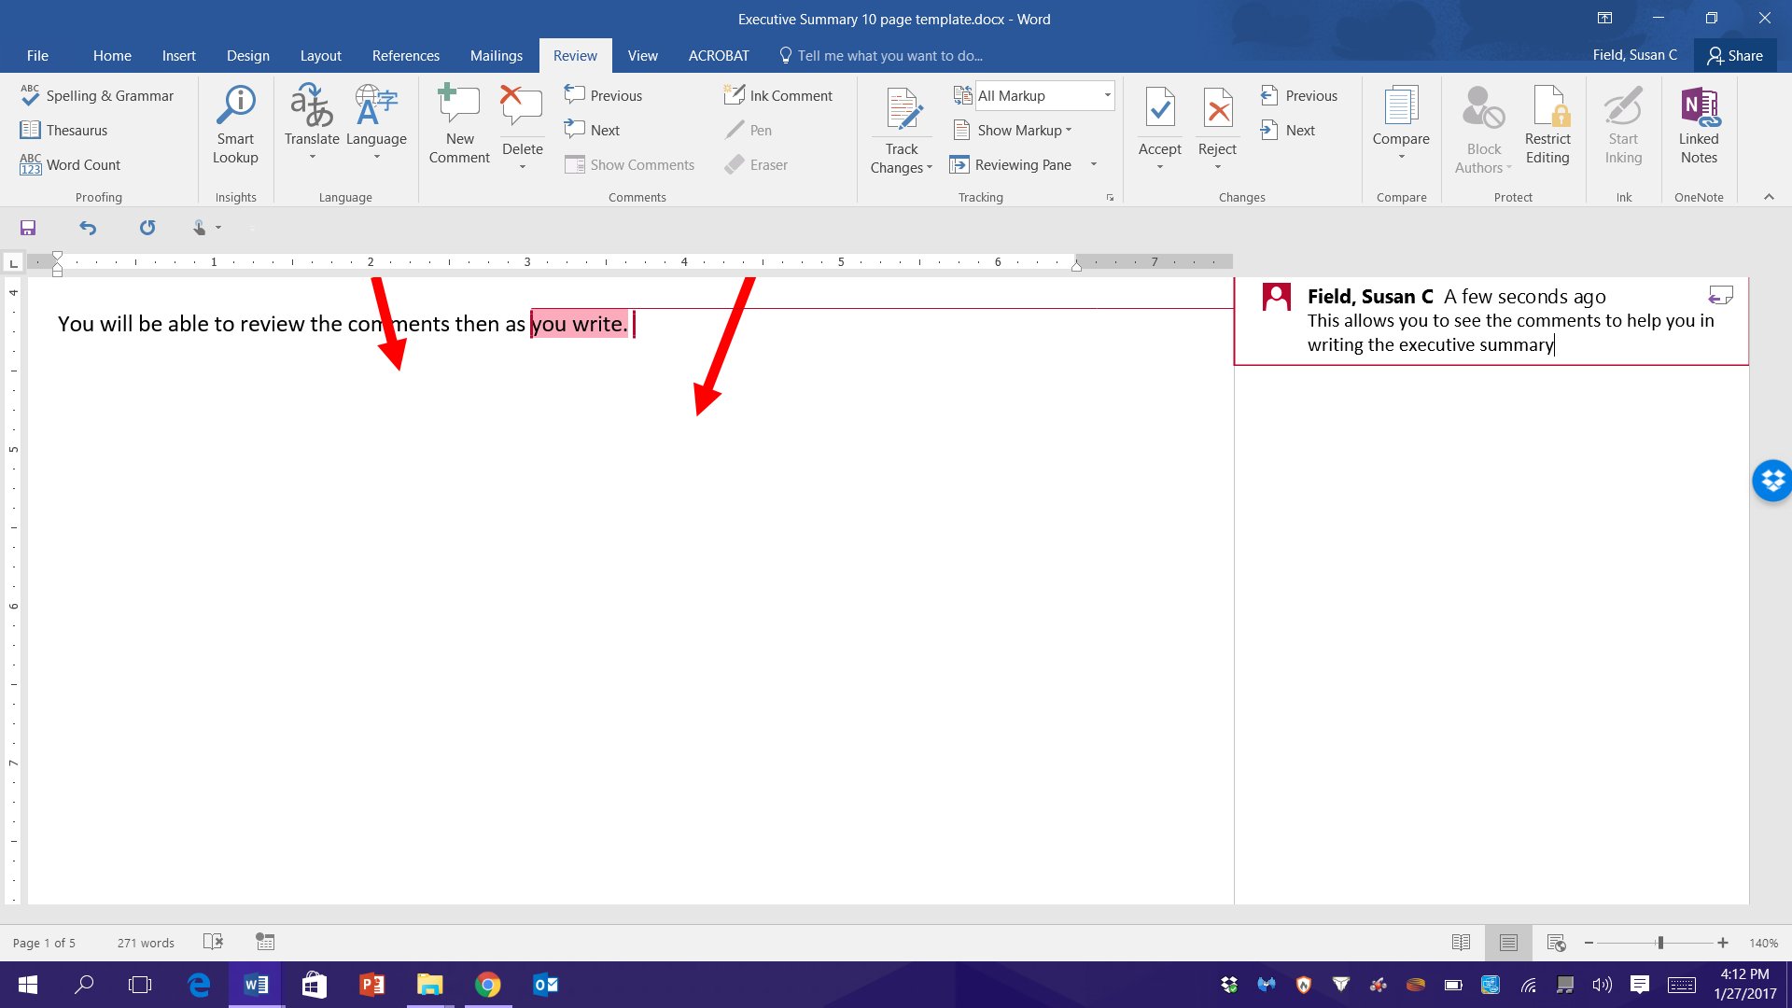

Standard I: Culture of Excellence – Program Outcomes
I-A. SEP: Our Nursing Program…

I-B. COLLECTING AND ANALYZING DATA: Our Nursing Program…
,

I-C COMPLETION RATES: Our nursing program…
,

I-D. NCLEX
,

I-E. EMPLOYMENT RATES: The nursing programs employment rates are…
,

I-F. SATISFACTION: The nursing program satisfaction surveys…
,

Standard II: Culture of Integrity and Accountability – Mission, Governance, and Resources
II-A. MISSION, CORE VALUES, GOALS:
,

II-B. FACULTY AND STUDENT GOVERNENCE:

II-C. COMMUNITY OF INTEREST:

II-D. PROGRAM PUBLICATIONS:

II-E. NURSE ADMINISTRATOR:

II-F. RESOURCES:

II-G. NURSING PROGRAM RESOURCES:

Standard III: Culture of Excellence and Caring – Faculty
III – A. FACULTY:

III - B. PRECEPTORS:

III – C. FACULTY SUPPORT:

III – D. FACULTY OUTCOMES:

Standard IV: Culture of Excellence and Caring – Students.
IV – A. STUDENT SERVICES:

IV – B. STUDENT POLICIES:

IV – C. POLICY CHANGES:

IV – D. FORMAL COMPLAINTS:

IV – E. STUDENT RECORDS:

Standard V: Culture of Learning and Diversity – Curriculum and Evaluation Processes
V – A: STUDENT LEARNING OUTCOMES:

V – B: PROFESIONAL STANDARS:

V – C: CURRICULUM DESIGN:

V – D. CURRICULUM UP TO DATE:

V – E. EVIDENCE BASED PRACTICE AND COLLABORATIVE PRACTICE:

V – F. EXPERIENTIAL LEARNING:

V – G. VARIETY OF TEACHING/LEARNING/EVALUATION:

V – H. EVALUATION STRATEGIES:

V – I. TECHNOLOGY:

V – J. CURRICULUM REVIEW:

