Faculty Course Evaluation QI Plan
Quality Improvement Plan-Do-Study-Act Template
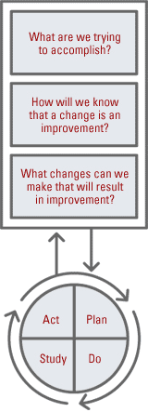
Quality Improvement is one of the QSEN (Quality Safety Education in Nursing) outcomes for nursing (www.qsen.org). It is important to start infusing quality improvement terms within your nursing programs if you have not been using the terms.

The Plan-Do-Study-Act method is one means of demonstrating continual quality improvement. Using this method for faculty improvement of your courses is a great way to get the faculty oriented to quality improvement methods.

The Plan-Do-Study-Act method is a way to test a change in your nursing courses and by following the four steps, it guides the thinking process similar to the nursing process. One of the values of this method is that it allows faculty to not only evaluate their classes, but to implement improvement methods, evaluate them, and continue testing until the goal is achieved. As nursing faculty we do these things subconsciously, but writing them down and “closing” the circle with the evaluation of what you have completed demonstrates the quality that we have in our nursing programs.

For more information on the Plan-Do-Study-Act, go to the IHI (Institute for Healthcare Improvement) Web site or this PowerPoint presentation on Model for Improvement” (www.ihi.org/knowledge/pages/tools/plandostudyactworksheet.aspx).

Faculty Name:
Course:
Sem/  Year | Course:
Sem/  Year | Survey Results |  | Plan: | Do/Study | Act
Sem/  Year | Strengths: What were the strengths that were identified in the survey? | Suggestions: What were the suggestions from students for improvement of your course? | Goal:  What is your goal for improvement?  Action Plan:  What is your action plan for your course to accomplish your goal? | Do:  Did you implement your plan?  Study:  Did you meet your goals? What were the results? | Act:  Did it work or not? If it did ?not work, what will you do differently next time? If it did work, will you continue it throughout the modification throughout your other courses?  Revised Action Plan:

If you make modifications to your plan to achieve your goal, then start at the Plan row on the template in the next column for continuing the Plan-Do-Study-Act process.

