Minnesota State College-Southeast Technical
Nursing Faculty Orientation Manual for Technology-based Systems
Developed and written by
Lisa Robertson, MSN, RN

Table of Contents

Introduction 3
Campus-wide Technology Systems 4
Strong Password Creation 5
Computer Network Drive: Faculty I-drive 8
Computer Network Drive: Department G-drive 11
Image Now 12
Institution-provided Resources 15
MicroMedex
Elsevier, Evolve, & Health Education Services Inc.
Cerner Academic Electronic Health Record & Simulation Lab
Lippincott NCLEX 3000 & 3500
Ebsco Databases
Turning Technologies Student Response Systems 18
Evolve Resources 22
Conclusion 23

Introduction
This instruction booklet for technology-based systems is a supplemental guide meant to complement the general orientation manual for nursing faculty at Minnesota State College-Southeast Technical. Several of the technology-based systems used in the college such as Desire 2 Learn (D2L), Information Storage and Retrieval System (ISRS), and Academic Performance Reporting System (APRS), have experts available for in-depth orientation as needed. Nursing faculty mentors will reiterate and reinforce the college-wide technology systems during the new faculty probation period. Within the nursing department, nursing faculty have become experts in several areas such as simulation, academic electronic health records (AEHR), and Elsevier products like Evolve learning management systems and Health Education Systems Inc. (HESI) testing systems. This manual will provide you with information and a place to start.

Campus-wide Technology Systems
New faculty will be introduced to members from the Information Technology (IT or Helpdesk) team and learn about the campus email system, D2L, Tegrity, ISRS, APRS, My Southeast Portal, ImageNOW, StarID, and other systems. Faculty may access Southeast Technical’s intranet from remote locations through the main website by going to Quick Links, then opening Remote Desktop Connection. Faculty can follow the instructions to open a remote connection to the College’s terminal server.
Additionally, faculty will be provided with information regarding utilization of the Minnesota State Colleges & Universities (MnSCU) system and Minnesota Management & Budget (MMB) employee self-service site. Many of these systems require strong passwords and will require faculty to change passwords every 60-90 days. Included in this manual are suggestions for creating strong passwords to improve safety and security for technology-based information.

Remember: The Southeast Technical IT team (Helpdesk) will NEVER ask you to verify email information or passwords through email. DO NOT click on links within suspicious emails you have opened. You may forward any suspicious emails to the Helpdesk to help ensure security of private information.

Strong Password Creation
Southeast Technical has several technology-based systems that require faculty and staff to change passwords at specific intervals. This general information regarding good methods in creating strong passwords was found online at the sites indicated. Strong password creation is integral to maintaining the safety and security of valuable educational data such as exams, student personal information, and grades. Nursing faculty are strongly encouraged to create passwords that are challenging to discover but easy to remember. Please consult the Helpdesk or the nursing Technology Committee lead faculty if you have questions.

*Two essential password rules (information found at http://www.thegeekstuff.com/2008/06/the-ultimate-guide-for-creating-strong-passwords/

These two rules are the bare minimum that you should follow while creating a password.
Rule 1 – Password Length: Stick with passwords that are at least 8 characters in length. The more character in the passwords is better, as the time taken to crack the password by an attacker will be longer. 10 characters or longer are better.
Rule 2 – Password Complexity: Should contain at least one character from each of the following group. At least 4 characters in your passwords should be each one of the following.
- Lower case alphabets
- Upper case alphabets
- Numbers
- Special Characters/symbols ` ~ ! @ # $ % ^ & * ( ) _ + - = { } | [ ] \ : " ; ' < > ? , . /

I call the above two rules combined as “8 4 Rule” (Eight Four Rule):
- 8 = 8 characters minimum length
- 4 = 1 lower case + 1 upper case + 1 number + 1 special character.
Just following the “8 4 Rule” will be a huge improvement and instantly make your password much stronger than before. If your banking and financially sensitive website passwords do not follow the “8 4 Rule”, I strongly suggest that you stop everything now and change those passwords immediately to follow the “8 4 Rule”.

Guidelines for creating strong passwords:
- Follow the “8 4 Rule”. Like mentioned above, this is the foundation of creating a strong password.
- Unique Characters. Should contain at least 5 unique characters. You already have 4 different characters if you’ve followed “8 4 Rule”.
- Use a passphrase. If you don’t want to use a password management tool, use Passphrase to easily remember the passwords. You can use initials of a song or a phrase that are very familiar to you such as “Passwords are like underwear, change yours often!” phrase can be converted to a strong password “Prlu,Curs0!”

Guidelines for avoiding weak passwords:
Avoid the following in your passwords, without exception.
- Password same as username or part of the username
- Name of family members, friends, or pets.
- Personal information about yourself or family members. This includes the generic information that can be obtained about you very easily, such as birth date, phone number, vehicle license plate number, street name, apartment/house number etc.
- Sequences such as consecutive alphabets, numbers, or keys on the keyboard e.g. abcde, 12345, qwert.
- Any dictionary words with number or character in front or back are unacceptable
- Real word from any language including dictionary words.
- Word found in dictionary with number substitution for word look-alikes such as replacing the letter O with number 0. i.e passw0rd.
- Any of the above in reverse sequence
- Any of the above with a number in front or back.
- Empty password

*The College of New Jersey offers this additional information to help you create a strong password (website http://www.tcnj.edu/~it/security/passwords.html )

Following are examples of some techniques for creating passwords.
1. Use a word with one or two digits embedded in it.
Examples: HOU32SE#, MON42DAY, TAB87LE%
2. Make up an acronym based on a nursery rhyme, a favorite song or movie, or a sentence.
Examples:
MHALL76# - Mary Had A Little Lamb
MDHF#88- My Dog Has Fleas#
OTGDY4*8 - Only the Good Die Young (Billy Joel)
TERM2*12 - Terminator 2
3. Use a three character pronounceable word suffixed or prefixed with a one- or two-digit suffix or prefix.
Examples: DAM56, WAR34, 56DIG
4. Make up nonsense words that mean something to you by combining the first syllables of two words. However, avoid using standard abbreviations like "jan, feb, mar, etc." as part of your password.
Example: PUBPOL5% - Published Policy
5. Drop vowels or drop everything but the first 6 letters of a long word or two words.
Examples:
CLNDSK1# - clean desk
DEDICA5% - dedication
HOMEWO# 9- home work
6. Use special characters like #, $, and @. These too, can be inserted anywhere.
Example: UNI$VER9 - university
7. Misspell a word, drop a couple of letters or add some.
Examples:
MISTIFI@ - mystify
CELLEB59 - celebrate
RNYDY$17 - rainy day
8. Be creative! Try to choose a pattern that has meaning for you but that no one else can guess. For example, you might use upcoming events in your life. If you or one of your children has a major essay to write next month, you might create a password reflecting that event.
Example: MAJESS+7 - Major essay
Or if your 4th cousin, twice removed, is coming for a visit you might create a password such as the following one.
Example: 4CUZZ02#
9. Another pattern could be to choose meaningful words with a minimum of 10 letters and always use only the first 6 letters. Then add a special character as one of the choices. Note: Some systems have restrictions as to which special characters can be used as part of a password.
Examples:
ANNIVE$0 - anniversary
UNBEND# 9- unbendable
@UNBEND1 - unbendable
UN#BEND1- unbendable
The best password is one that is a random combination of numeric and alphabetic characters and special characters.
Example: 48KK43%V
On systems which allow upper case and lower case letters, use a combination of upper and lower case characters for your password.
Example: 4*hk8LP9
Computer Network Drive: Faculty I-drive
All Southeast Technical employees have an Individual Drive (I-drive) in which they can store information for the duration of their employment. Saving information to your I-drive is a safe way for you to organize your paperwork for classes, keep records of student performance, and document all of your work. Faculty and staff are strongly encouraged to save documents to their I-drive INSTEAD of their desktop. Some faculty use external hard-drives or thumb-drives to save documents. This is perfectly acceptable but we all know how easy it is to lose a thumb-drive. Students are also provided with access to an I-drive to which they can save documents for classes. Remind students to use their I-drive to save documents.
Your personal I-drive is Internet accessible from home through the Remote Desktop Connection link found on the Southeast Technical website. You will be connected remotely to the secure school network using this access so you can continue to work on projects and papers at any location without extra effort.
Microsoft Office is provided and supported on Southeast Technical computers but Microsoft Works is not. This makes an assumption that you understand how to open and save documents such as in Word (.doc;.docx), Adobe (.pdf), Excel (.xls;.xlsx) and PowerPoint (.ppt; .pptx). If you use Apple computer products at home, review information already provided on the College website or contact the Helpdesk for additional information as needed.
When you have been working on a document and wish to save it for future use, the next page shows what the computer screen will show when you choose SAVE AS:
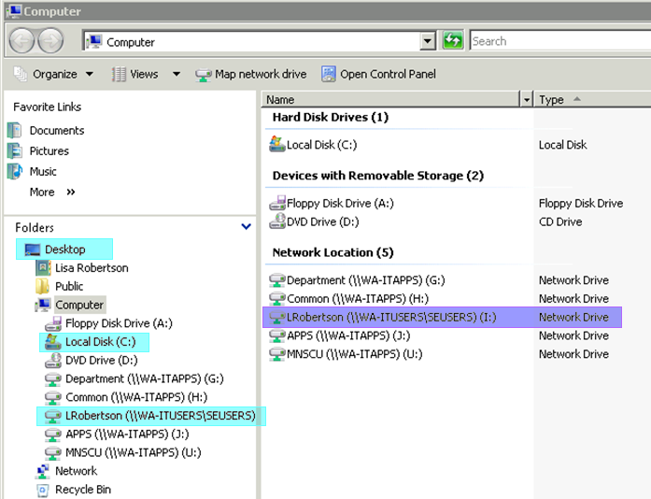
Your three easiest choices for saving documents are highlighted above in light blue on the left. The desktop and local disc (C-drive) may have information erased when IT performs reimaging every year. The third choice is my I-drive. As you can see, the I-drive on the right side (highlighted in purple) is actually a Network Drive, safely and easily accessible by you from any internet connection. This is the best place to save documents.

Upon reflection, my labeling of folders could use some work, but I can usually find any document I need when I need it through a search. That is the important part!
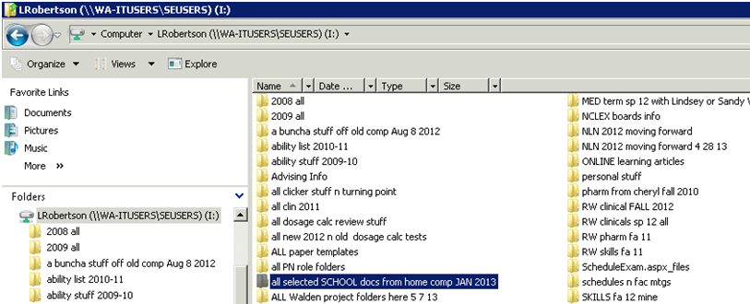

Network Computer Drive: Department G-drive
The G-drive is a Department-specific network drive accessible by Southeast Technical staff and faculty. This is an area where nursing faculty can upload information meant for sharing with all other nursing faculty in the department. Nursing faculty must handle documents in the G-drive with care. Moving, changing, or deleting documents in the G-drive could result in significant loss of valuable documentation for the department. Please consult your nursing faculty mentor, the campus lead faculty, or the Technology Committee lead faculty for more information when using the G-drive.

Image Now
Image Now is a virtual file cabinet used by Southeast Technical staff and faculty for storage and retrieval of student information. The Nursing Department uses Image Now to review student requirements such as CPR cards, background checks, letters of concern, advising worksheets, and other necessary forms. Initial access to Image Now is provided by the Southeast Technical IT team (Helpdesk).
Look for this icon on your desktop. | 
- Generally, your login is first initial & last name, one word, all in small letters, such as nwozney or jjohnson. Please contact the Helpdesk if you have a name change.
- Your initial password will be given to you by the Helpdesk and must be changed every 180 days.
- The website used for changing your password is https://secure.mnsu.edu/imagenow
Our recommendation is for Nursing Faculty to change this password every time you change your computer access login/email password for consistency. Please see Strong Password Creation (p. 5) for a list of suggestions. If you let your access lapse, it can be a difficult process to regain access to Image Now.
How to Utilize Image Now
You can access this program through the college laptop provided by IT (double click the icon on your desktop) or, if on Remote Desktop Connection from home, using this website https://dimm.campus.mnsu.edu/webnow/ . You may have to install Java to access from off-campus using Remote Desktop.
- Fill in your user name and password.
- Click on “All documents” then search in the “TAB” file. See below for example.
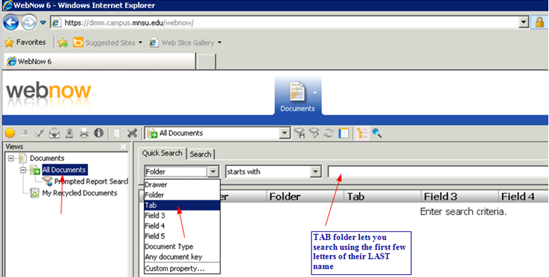
I typed in the name Johnson, using the TAB search. You may need to change the sizes of the headings to see the information more clearly. When in the program, place your cursor on the darker grey perpendicular line just to the left of “Document Type”. When you see the cursor change into a two-headed arrow, hold down the left click and slide the field to a different size.
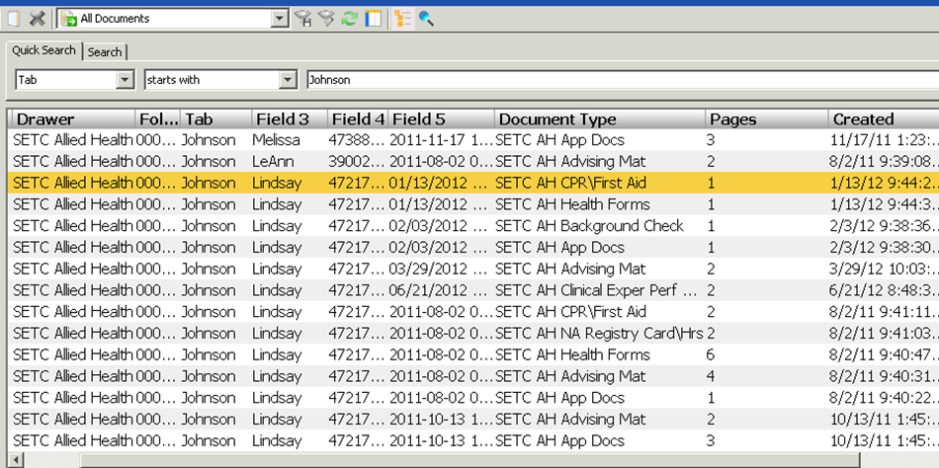

Student information is entered using this method
- Field 3 – first name
- Field 4 – student’s Southeast Technical ID number (Tracy & Shelly need this on all forms from faculty)
- Field 5 – date of entry, usually matches date created
- Document type – helps when searching for specific document, such as CPR card
To view the document, double-click to open it. Close the document when done. To exit Image Now, click on disconnect. Our goal is to be paperless and maintain confidentiality, so please do not print student records.

If you have used Remote Desktop Connection, remember to LOG OFF prior to shutting down your computer.

Institution-provided Resources
Southeast Technical maintains several institution resources to enable students to perform research, explore reputable websites, and access nursing-related programs. All computers on campus have desktop shortcuts to Micromedex, Evolve Learning Resources from Elsevier, Citrix CernerWorks Academic Electronic Health Record, and Lippincott’s NCLEX preparatory programs. Additionally, Ebsco databases are available through the Southeast Technical website.
Truven MicroMedex Professional Academic Program has reliable clinical information available from any location. According to the website, this includes all the unbiased, referenced information about drugs, toxicology, diseases, acute care, and alternative medicine you may need to make informed clinical judgment and treatment decisions. Information regarding access to MicroMedex can be found in the NEWS items on D2L general nursing websites.
Evolve is an online learning solution that is designed to work in conjunction with specific textbooks from Elsevier publishing and provide Internet-based course content that reinforces and expands on the concepts delivered in the classroom. Elsevier is a world-leading provider of scientific, technical and medical information products and services. Evolve Learning Resources are available for both students and instructors. Depending on the corresponding textbook and the user-type, the Learning Resources can include web-links, tip sheets, checklists, test banks, PowerPoint slides, image collections, instructor's manuals, teaching tips, FAQs, and more (http://www.elsevier.com/electronic-products/evolve). Additionally, Southeast Technical utilizes Evolve products such as case studies, ADN level patient reviews, category-specific practice tests, and a nursing skill video series to enhance the learning environment for student success.
Elsevier also owns Health Education Systems Incorporated (HESI), a Houston-based firm that specializes in developing high-quality diagnostic tests for nursing and allied health markets. A primary objective of HESI products is to provide faculty with the tools to predict how their students will perform on the NCLEX exam, a licensure exam for nursing students. Faculty will meet with the nursing Technology team lead faculty several times during their probation period to familiarize themselves with Evolve and the various components it encompasses.
Southeast Technical provides a link to the Citrix CernerWorks application portal on all computers on campus. CernerWorks is an Academic Electronic Health Record (AEHR) in which students create a personalized record and document laboratory and simulated experiences. Faculty can review student documentation and provide feedback. Faculty may also use CernerWorks at home by opening https://cernaes.cernerworks.com/CSS/auth/login.aspx and downloading the Citrix XenApp Web Client application as seen below. Detailed introduction to CernerWorks is provided by our nursing Simulation Lab experts and reinforced during clinical lab instruction and through student assignments. Additionally, introduction to the Simulation Lab and the various tools utilized in the Sim Lab is deferred to our Simulation experts and not addressed in this manual.
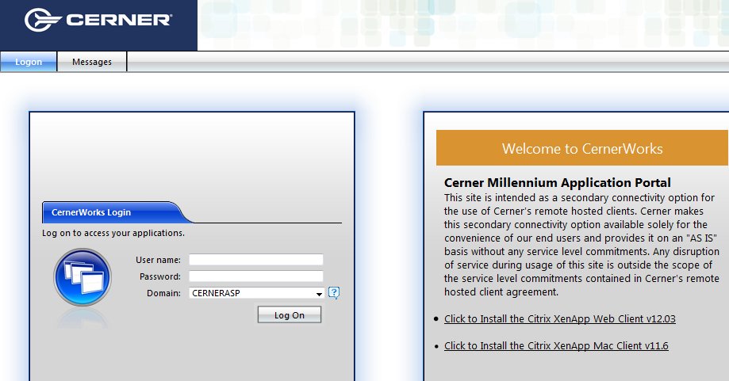
Lippincott, Williams, & Wilkins NCLEX preparatory services, NCLEX 3000 (PN level) and NCLEX 3500 (RN level), are an institutional-based nursing student study program with more than 3,000 NCLEX-style review questions in each level of study. This service is available only on campus. The program provides pretests to evaluate strengths and weaknesses of the student, allows customizable reviews with instant feedback, customizable tests with detailed analysis and feedback, plus study aids.
Finally, students can use the Learning Resource Center, through Library Services, to access Ebsco research databases, online newspapers, electronic books, and government resources while on campus or through Remote Desktop Connection. Ebsco contains academic, business, and multidisciplinary databases which include full text of over 7,000 publications. Nursing faculty can familiarize themselves with reliable reputable research opportunities to share with students.

Turning Technologies Student Response Systems
Student Response Systems (Clickers) Software Installation
To get ready to use clickers, do NOT download the software that comes with the clickers on the DVD and do NOT download the software that they tell you to download in their directions with the box of clickers. INSTEAD, download the software from their website.
- Go to their website http://www.turningtechnologies.com/
- Click the green box on the right that says “downloads”
- Click on polling software “New TurningPoint” (this replaces TurningPoint Anywhere)
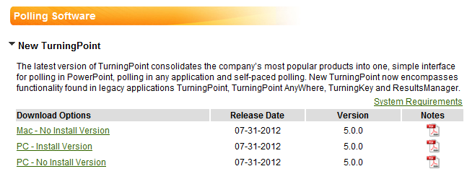
- Click “PC – install version”
- Complete all the information and identify your institution as “Minnesota State College-SE Technical”.
- Click submit
- Click download (the big black box on the left)
- Click “save file” and allow program to download, may take a few minutes
- When the “download complete” box pops up, choose RUN or double click on the file that you just saved and click RUN. If you don’t see it, look for the file in your task bar at the bottom of the screen – the download box may have accidentally been minimized
- The TurningPoint installation wizard will begin, click “Next”
- Click the box to “I accept” and choose where you want the program to be installed
- The most logical place for this program to be installed is on the C drive, in Program Files (x86) as identified in the box below

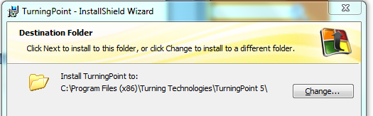
- Follow the prompts to INSTALL
- This icon should now be on your desktop:
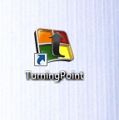
This concludes the INSTALLATION of the product. You will need to reinstall this program after IT reimages your computer. You may discuss this concern with IT when they request computers for summer reimaging.
Using the TurningPoint Student Response Systems (Clickers)
Double click on the “TurningPoint” icon (shown above) on the desktop to open the program. These following options appear; choose “Anywhere Polling”.
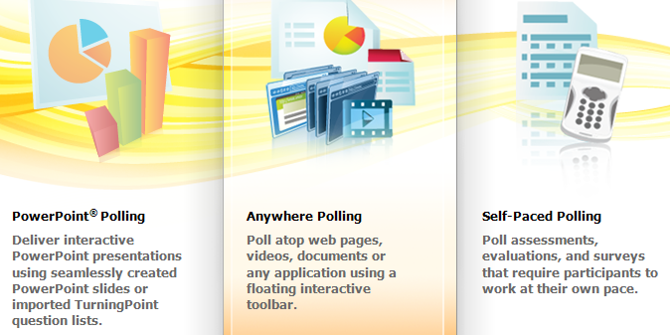

“Anywhere Polling” allows you to use a floating interactive toolbar over the top of any document, webpage, or application. A small toolbar will appear in the upper right corner of your screen. You can open your document or presentation at any time.
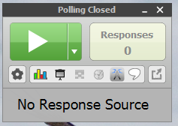

You can move the toolbar as you wish. Hand out Turning Technology student response clickers to your students, insert the Response Card Receiver into your USB port, and you are ready to poll your students. When you come to a question created for the students, do the following to start receiving answers:
- In the Polling toolbar, click on the small down arrow in the middle of the toolbox
- Select the number of possible answers in the question, polling opens, and students can begin to answer. If you want to use a 30 second timer, click on the “Clock” symbol in the toolbox. Once the clock runs down the polling will close automatically.
- To close polling on each question without a timer, click on the big square symbol in the toolbox. Polling will end and the student’s responses will show on the screen. If you want to switch back and forth between the question and the polling graph, click below on the graph chart icon and toggle between screens. You will have to click back into your presentation or document to continue onto the next screen in your presentation.
- When you have finished polling the students, close the session by exiting the toolbar. The system will prompt you to save your data if preferred. See Tim’s instructions below to create or save a report. If you do not want to save your data, exit this website also.
- Then go to bottom right of your screen to click on “safely remove hardware” before removing the Response Card Receiver from your USB port.

To get a report of the questions you have asked and the answer data, click on the little down arrow in the lower left corner of the toolbox and place the cursor over “Tools” and select “Reports”. For the current session, click on the little down arrow for “Available Reports” and select “Results by Question”. This will bring up the results for each question asked. You can print or save the report for future reference.

Evolve Resources
Southeast Technical faculty members will meet with the nursing Technology lead faculty several times during their probationary period to learn about Evolve resources and HESI. Detailed instructions have been posted on the D2L general nursing sites regarding creating an account, getting access to and using textbook resources, case studies, ADN patient reviews, video series, and practice exams. The nursing Technology lead faculty will provide new faculty with access to most of these resources through Elsevier and HESI customer service representatives. Other items of interest include PageBurst online books and Exam View resources. When we discuss HESI testing and remediation, topics include giving an exam, creating reports using HESI results, and reviewing remediation progress of students.
Additionally, Evolve resources provide information specifically for faculty at their website Elsevier Advantage which includes webinars, white papers, and training opportunities. The Evolve learning management system is deeply embedded within the nursing program to provide various opportunities to increase student success. Learning all that Evolve has to offer will take time and effort from all nursing faculty members to support the novice nurse educator.

Conclusion
Technology influences multiple aspects of nursing and nursing education. The faculty at Southeast Technical has many technological systems to review, learn, and utilize to enhance student success. Nursing faculty are experts in areas such as simulation, academic electronic health records (AEHR), and Elsevier products like Evolve learning management systems and Health Education Systems Inc. (HESI) testing systems. This orientation manual for technology-based systems will serve as a guide to create the opportunities for learning in the nursing department. Consult the nursing department Technology lead faculty for more information.

