SKILL FOCUS: Clinical Handoff Report DISCIPLINE: Nursing LEVEL: 1
NURSING CLINICAL HANDOFF REPORT | LEVEL: 1

CLINICAL HANDOFF REPORT

Estimated Time: Flexible

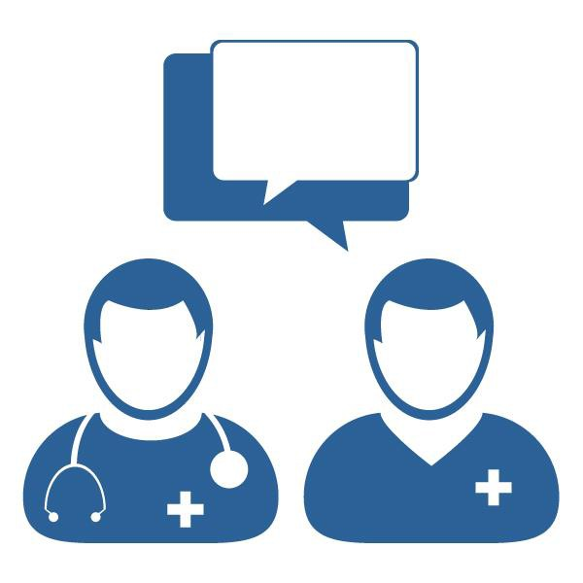Scan to Begin

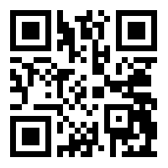

CASE STUDY OVERVIEW

This case study has been designed with maximum flexibility for instructors to augment the reality of handoff reports in the simulation lab or classroom setting. To enhance communication-related learning activities, instructors may select QR Codes for various report videos from the QR Code tables below. In addition, these report videos can be incorporated into group classroom activities by tapping on the associated Nursing Reports tab on the iPad and displaying the media using a projector.

LEARNING OBJECTIVE

1. Practice identifying clinically relevant information and prioritizing tasks using videos that augment the reality of a handoff report for patient.

NURSING CLINICAL HANDOFF REPORT | LEVEL: 1

NURSING CLINICAL HANDOFF REPORT | LEVEL: 1
QR CODE TABLE

NURSING REPORTS
CLINT 1  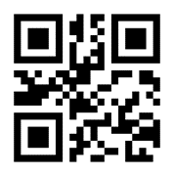 | PAULA 1  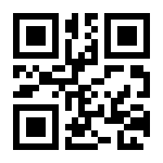 | LAURA 1  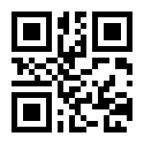 | MARIA 1  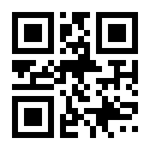
MARIA 2  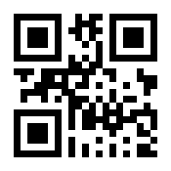 | OLIVIA 1  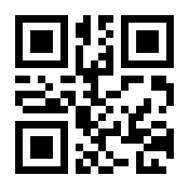 | OLIVIA 2  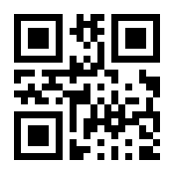 | OLIVIA 3  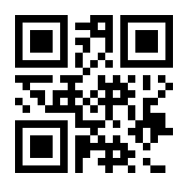
MICHAEL 1  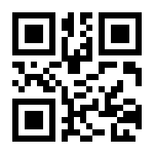 | MICHAEL 2  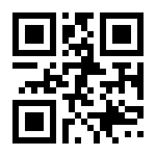 | PATRICK 1  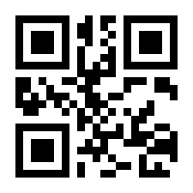 | PATRICK 2  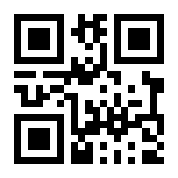
NOAH 1

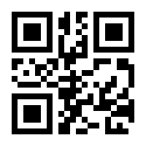

NURSING CLINICAL HANDOFF REPORT | LEVEL: 1

FACILITATOR INSTRUCTIONS

This case study was designed for maximum flexibility for the facilitator to augment the reality of handoff reports in simulations and learning activities in the classroom and/or lab. QR Codes can be placed on a simulator, manikin, printed image of a “patient,” or given to a student who is playing the role of a “patient.”
Alternatively, in an instructor-led discussion, after scanning the QR Start Code, these videos can be accessed via tabs and buttons on the iPad. They can be displayed on a projector screen using a VGA adaptor connected to the iPad or via “Airplay” and an Apple TV.

SUGGESTED USES:

- In a lab setting: See “Sample Teaching Plans” below.
- In simulation: Choose a QR Code from above. Build a scenario around that report and your desired learning objectives. Have students get report prior to simulation by scanning the above start QR Code and then the QR Code you choose to base the scenario around.
- In a classroom: Attach the iPad to the teaching station using a VGA connector or use “Airplay” associated with an Apple TV. Have students listen to a report. Then, discuss clinically relevant information and how to prioritize care based on report.

NURSING CLINICAL HANDOFF REPORT | LEVEL: 1

SAMPLE TEACHING PLAN – A

& Discussion Points
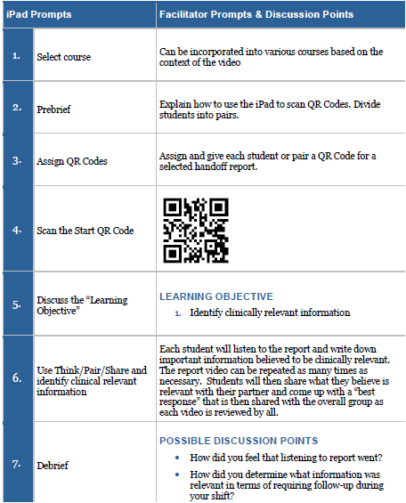

NURSING CLINICAL HANDOFF REPORT | LEVEL: 1

- What would be your priorities for patient care at this time and why?
- Take away: What have you learned from this activity that you will take to your clinical practice?
8. | End Scenario | - Students can exit at any time by tapping the Exit tab and following instructions.  - Please have each student complete the provided survey.

NURSING CLINICAL HANDOFF REPORT | LEVEL: 1

SAMPLE TEACHING PLAN – B

& Discussion Points
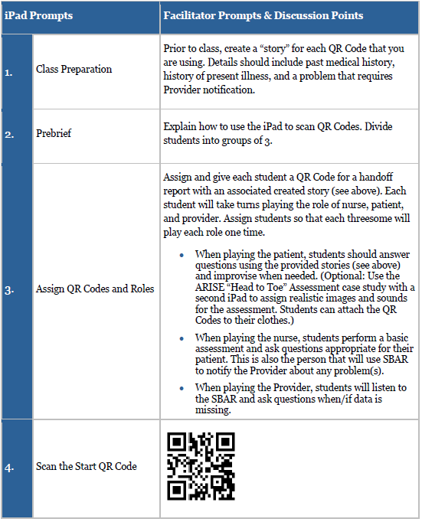

NURSING CLINICAL HANDOFF REPORT | LEVEL: 1

5. | Discuss the “Learning Objective” | Learning Objective  1. Use SBAR communication
6. | Obtain patient history & assess patient | One student plays the role of the patient. One student plays the role of the nurse. The student playing the Provider role should be secluded and not listening to the assessment/history taking. The caregiver will assess the patient and take a history.
7. | Perform SBAR Communication | Using the data gathered in Step 6, the “nurse” will provide SBAR communication with the “Providers.” Do this at bedside so that patients can be a part of the process.  During this time, have the “patients” perform a brief written critique of the “caregiver’s” SBAR skills.
8. | Repeat | Repeat the above process until all students have played each role one time.
9. | Group Discussion | Using the written critiques, have groups discuss the SBAR process prior to the large group Debrief.  - What went well?  - What needs improvement?  - How does SBAR aide or improve patient care?  - Keeping SBAR in mind, if you could do any part of your assessment or history taking over, what would it be and why?
10. | Debrief | Possible Discussion Points  - Relate discussion to learning objective.  - How do you feel the SBAR communication went?  - Were things missed in the assessment/history taking that could have altered the Provider’s recommendations?  - In what other situations could SBAR be used to improve healthcare communications and how?  - If you could re-do your SBAR, is there anything you would change or improve?

NURSING CLINICAL HANDOFF REPORT | LEVEL: 1

 |  | - Take away: What have you learned from this activity that you will take to your clinical practice?
 | End Scenario | - Students can exit at any time by tapping the Exit tab and following instructions.  - Please have each student complete the provided survey.

NURSING CLINICAL HANDOFF REPORT | LEVEL: 1
REFERENCES

Dreifuerst, Kristina Thomas (2012). Using debriefing for meaningful learning to foster development of clinical reasoning in simulation. Journal of Nursing Education, 51(6), 326-333. doi:http://dx.doi.org/10.3928/01484834-20120409-02

International Nursing Association for Clinical Simulation and Learning (2016). Standards of Practice: Simulation. Downloaded from http://www.inacsl.org/i4a/pages/index.cfm?pageid=3407

This work by the Wisconsin Technical College System TAACCCT IV Consortium is licensed under a Creative Commons Attribution 4.0 International license.
Third party marks and brands are the property of their respective holders. Please respect the copyright and terms of use on any webpage links that may be included in this document.
This workforce product was funded by a grant awarded by the U.S. Department of Labor’s Employment and Training Administration. The product was created by the grantee and does not necessarily reflect the official position of the U.S. Department of Labor. The U.S. Department of Labor makes no guarantees, warranties, or assurances of any kind, express or implied, with respect to such information, including any information on linked sites and including, but not limited to, accuracy of the information or its completeness, timeliness, usefulness, adequacy, continued availability, or ownership. This is an equal opportunity program. Assistive technologies are available upon request and include Voice/TTY (771 or 800-947-6644).c

