SKILL FOCUS: Patient Assessment DISCIPLINE: Multidiscipline LEVEL: 1
HEAD TO TOE ASSESSMENT | LEVEL: 1

HEAD TO TOE ASSESSMENT

Estimated Time: Flexible

Scan to Begin

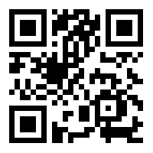

CASE STUDY OVERVIEW

This case study has been designed with maximum flexibility for instructors to augment the reality of patient assessment in the simulation lab or classroom setting. Instructors may select QR codes for various images, sounds and videos to incorporate into a learning activity from one or all of the following categories: Cardiovascular, Pulmonary, GI/GU, Integumentary and Equipment. See the Media table below for the sounds and images that are included under each category. This media can be incorporated into a group classroom learning activity tapping on the associated tab on the iPad and displaying the media using a projector.

LEARNING OBJECTIVES

1. Perform a physical assessment using images and sounds that augment the reality of a manikin or standardized patient.

HEAD TO TOE ASSESSMENT | LEVEL: 1

QR CODE TABLE

 | Cardiovascular | Pulmonary | Abdomen | Integumentary | Equipment/ Other | ECG
A | CV – A  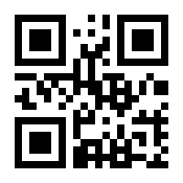 | P – A  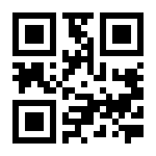 | A – A   | I – A  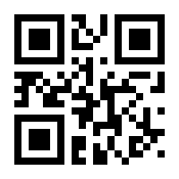 | E/O – A  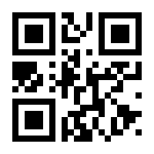 | ECG – A  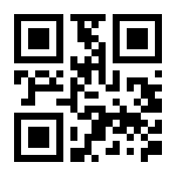
B | CV – B  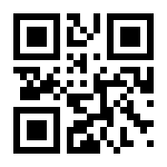 | P – B  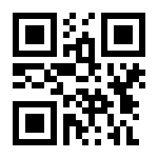 | A – B  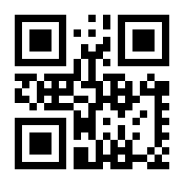 | I – B   | E/O – B   | ECG – B  

HEAD TO TOE ASSESSMENT | LEVEL: 1

C | CV – C  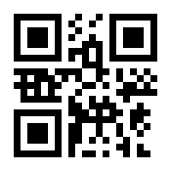 | P – C   | A – C  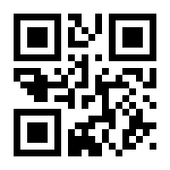 | I – C  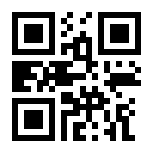 | E/O – C  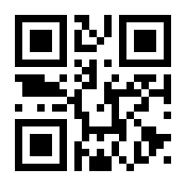 | ECG – C  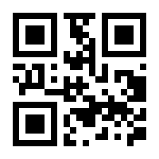
D | CV – D   | P – D   | A – D  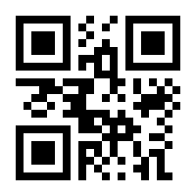 | I – D  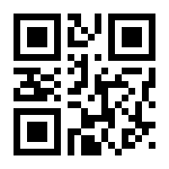 | E/O – D  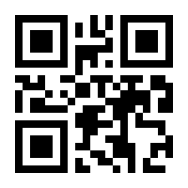 | ECG – D  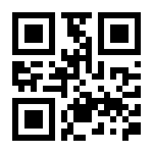
E | CV – E   | P – E  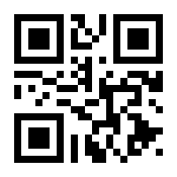 | A – E   | I – E   | E/O – E  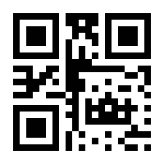 | ECG – E  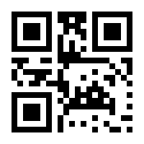
F | CV – F  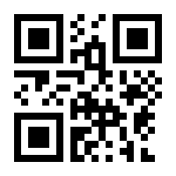 | P – F   |  | I – F  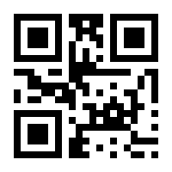 | E/O – F  
G | CV – G  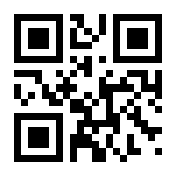 | P – G  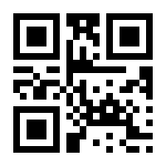 |  | I – G  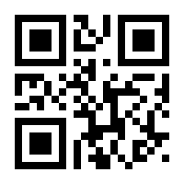 | E/O – G  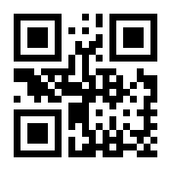

HEAD TO TOE ASSESSMENT | LEVEL: 1

H | CV – H   | P – H  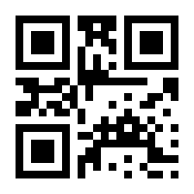 |  | I – H  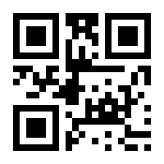 | E/O – H  
I | CV – I  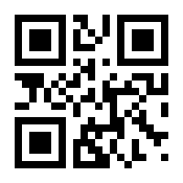 | P – I   |  | I – I  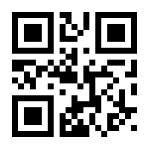 | E/O – I  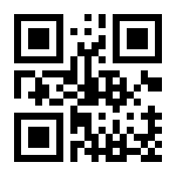
J | CV – J  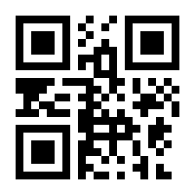 | P – J   |  | I – J  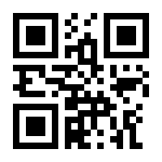 | E/O – J  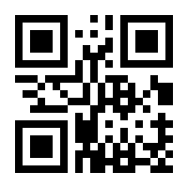
K |  | P – K  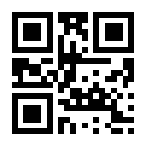 |  | I – K  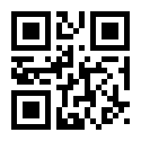 | E/O – K  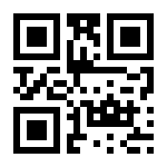
L |  | P – L  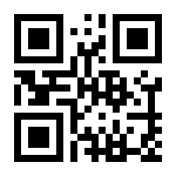 |  | I – L  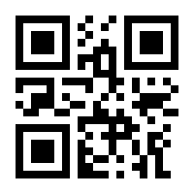 | E/O – L  

HEAD TO TOE ASSESSMENT | LEVEL: 1

M |  | P – M   |  | I – M  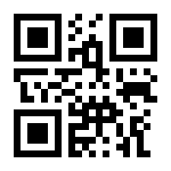 | E/O – M  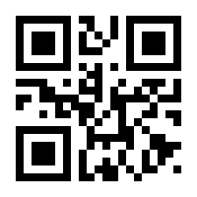
N |  | P – N   |  | I – N   | E/O – N  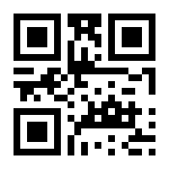
O |  | P – O  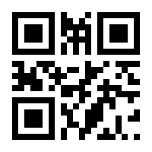 |  | I – O  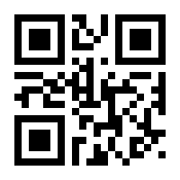
P |  | P – P   |  | I – O  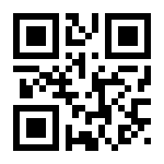
Q |  | P – Q   |  | I – Q  

HEAD TO TOE ASSESSMENT | LEVEL: 1

R |  | P – R  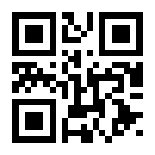 |  | I – R  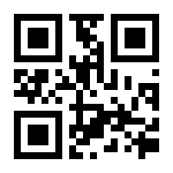
S |  | P – S   |  | I – S  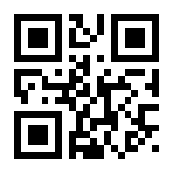
T |  | P – T  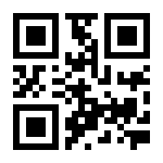 |  | I – T  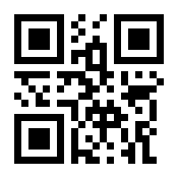
U |  | P – U   |  | I – U  
V |  | P – V  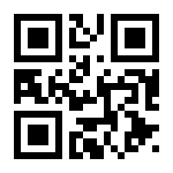 |  | I – V  

HEAD TO TOE ASSESSMENT | LEVEL: 1

W |  | P – W  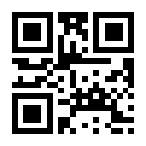 |  | I – W  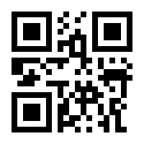
X |  |  |  | I – X  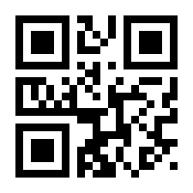

SKILL FOCUS: Patient Assessment DISCIPLINE: Multidiscipline LEVEL: 1
HEAD TO TOE ASSESSMENT | LEVEL: 1

QR CODE KEY

 | Cardiovascula r | Pulmonary | Abdomen | Integumentary | Equipment/ Other | ECG
A | Normal | Normal Adult | Normal Adult BS | Staples | IV Site Hand | ST Elevation
B | S3 | Wheezing | Newborn BS | Sutures | IV Site Antecubital | ST  Depression
C | S4 | Crackles | Seat Belt Sign | Edema | IV Site Forearm | PVCs
D | Murmur | Pleural Friction Rub | ABD Pad | Venous Ulcer | IV Site Hand: Dark Skin | Atrial Fibrillation
E | Newborn | Stridor | Urinal with Urine | Arterial Wound A | PICC Site | Ventricular Fibrillation

HEAD TO TOE ASSESSMENT | LEVEL: 1

F | Irregularly Irregular Rhythm | Rhonchi |  | Arterial Wound B | BiPAP
G | Capillary Refill | Diminished |  | Diabetic Ulcer | Pacemaker
H | JVD | Normal Newborn |  | Heel A | Foley Bag
I | Decreased Perfusion | Neonatal Grunting |  | Heel B | CABG with MSI, Chest Tube Site & Pacer Wires
J | 12 Lead ECG Attached | Croup Cough |  | Heel C | Chest Tube

HEAD TO TOE ASSESSMENT | LEVEL: 1

K |  | Flail Chest |  | Heel D | Chest Tube Site
L |  | Pectus Excavatum |  | Buttocks A | Pulmonary Artery Catheter
M |  | Pectus Carinatum |  | Buttocks B | Triple Lumen Central Line
N |  | Digital Clubbing |  | Sacral Wound A | IV Site Hand: Child
O |  | Sputum |  | Sacral Wound B

HEAD TO TOE ASSESSMENT | LEVEL: 1

P |  | FEV1 Results |  | Sacral Wound C
Q |  | Peak Flow Results |  | Sacral Wound D
R |  | Ventilator |  | Sacral Wound E
S |  | Sedated on Ventilator |  | Ear Wound
T |  | Scoliosis |  | Mottling

HEAD TO TOE ASSESSMENT | LEVEL: 1

U |  | Kyphosis |  | Jaundice
V |  | JVD |  | Cyanosis
W |  |  |  | Steristrips
X |  |  |  | Arterial Thrombosis

HEAD TO TOE ASSESSMENT | LEVEL: 1

FACILITATOR INSTRUCTIONS

This case study was designed for maximum flexibility for multiple disciplines to augment the reality of simulations and learning activities in the classroom and/or lab. Use the QR Code Key to select the media and associated QR codes you would like to incorporate, then cut out the associated unlabeled QR Codes. QR Codes can then be placed on a simulator, manikin, printed image of a “patient,” or on the clothing of a student who is playing the role of a “patient.”
Alternatively, in an instructor-led discussion, after scanning the QR Start Code, these images and sounds may be quickly accessed via tabs and buttons on the iPad. They can be displayed on a projector screen using a VGA adaptor connected to the iPad or via “Airplay” and an Apple TV.

SUGGESTED USES:

- In a lab setting: Divide students into pairs. Assign one student to role play the “patient” and the other to role play the “health care professional.” Select various sounds or images associated with the overall learning objectives of the day. Place associated QR Codes on the outer clothing of partners and have students practice identifying the adventitious lung sounds, abnormal heart sounds, and/or wounds by scanning the QR Codes with an iPad. Students role-playing the “patient” can provide subjective data related to the sounds or images selected. Alternatively, the QR Codes can be placed on static manikins for assessment.
- In simulation: Select the sounds and/or images you desire to incorporate into your pre- designed simulation. Cut out the selected QR Codes and attach them to the simulator.
- In a classroom: Attach the iPad to the teaching station using a VGA connector or use “Airplay” associated with an Apple TV. Demonstrate sounds and/or images associated with the lesson by tapping on the tab associated with the desired category of media and then on the selected media.

HEAD TO TOE ASSESSMENT | LEVEL: 1

SAMPLE TEACHING PLAN

& Discussion Points
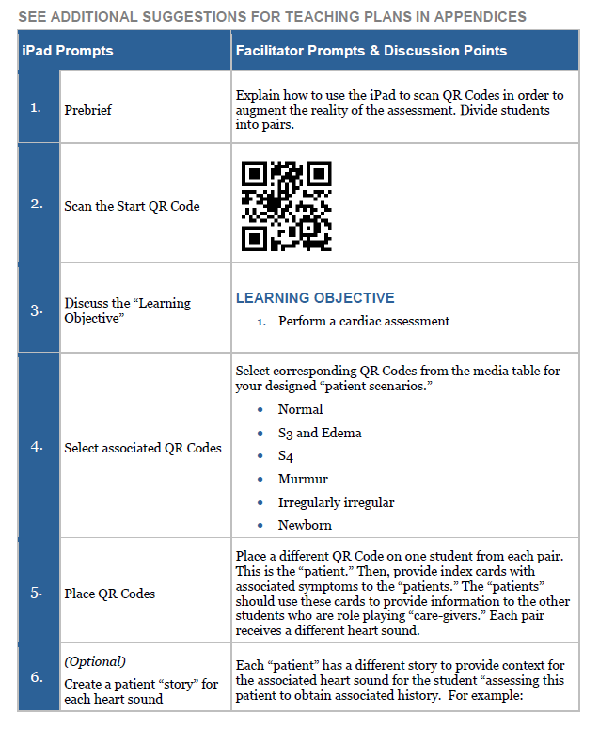

HEAD TO TOE ASSESSMENT | LEVEL: 1

Patient A: (S3 and Edema) History of chronic heart failure; has been feeling more short of breath lately; takes the following medications: Furosemide, Metoprolol, Lisinopril; has been eating more soup for dinner lately because too tired to cook
Patient B: (S4) History of hypertension; sometimes forgets to take Furosemide and Lisinopril
Patient C: (Irregularly irregular). History of atrial fibrillation; sometimes feels like heart is skipping around
Patient D: (Murmur) History of mitral valve prolapse; feeling more tired lately
Patient E (newborn): Baby Noah was born yesterday; obtain a heart rate
7. | Assess “patients” | The second student or “caregiver” in each pair should assess the “patients” including obtaining a focused health history. Then, have students write a narrative note of their findings. Optional: students could assess other “patients” from the other student pairs.
8. | Debrief | POSSIBLE DISCUSSION POINTS  - How did you feel the assessment went?  - Relate discussion to learning objective.  - What findings did you discover on assessment?  - How should the assessment findings be documented?  - What disease processes are associated with your assessment findings?  - If you could re-do your assessment, is there anything you would change or improve?  - Take away: What have you learned from this activity that you will take to your clinical practice?
 | End Scenario | - Students can exit at any time by tapping the Exit tab and following instructions.  - Please have each student complete the provided survey.

HEAD TO TOE ASSESSMENT | LEVEL: 1

APPENDIX A: SAMPLE TEACHING PLAN FOR PULMONARY ASSESSMENT

& Discussion Points
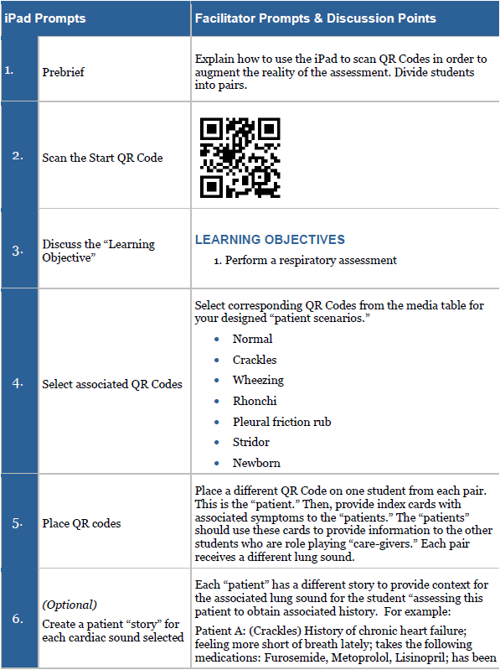

HEAD TO TOE ASSESSMENT | LEVEL: 1

eating more soup for dinner lately because too tired to cook
Patient B: (Wheezing) History of asthma; uses albuterol; was exposed to a cat today
Patient C: (Rhonchi) Has a cough; bringing up clear sputum
Patient D: (Pleural Friction Rub) Has pleurisy; hurts to cough.
Patient E: (Stridor- child) 5 year old child with an upper respiratory infection for a week; “barking” cough
Patient F: (Newborn) Baby Noah was born yesterday; obtain a respiratory rate
7. | Assess “patients” | The second student or “caregiver” in each pair should assess the “patients” including obtaining a focused health history. Then, have students write a narrative note of their findings. Optional: students could assess other “patients” from the other student pairs.
8. | Debrief | POSSIBLE DISCUSSION POINTS  - How did you feel the assessment went?  - Relate discussion to learning objective:  - What findings did you discover on assessment?  - How should the assessment findings be documented?  - What disease processes are associated with your assessment findings?  - If you could re-do your assessment, is there anything you would change or improve?  - Take away: What have you learned from this activity that you will take to your clinical practice?
 | End Scenario | - Students can exit at any time by tapping the Exit tab and following instructions.  - Please have each student complete the provided survey.

HEAD TO TOE ASSESSMENT | LEVEL: 1

APPENDIX B: SAMPLE TEACHING PLAN FOR WOUND ASSESSMENT

& Discussion Points
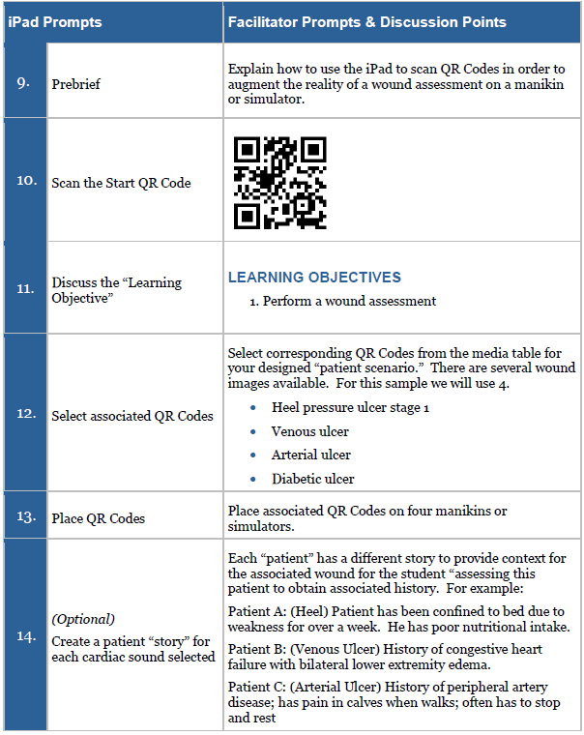

HEAD TO TOE ASSESSMENT | LEVEL: 1

 |  | Patient D: (Diabetic Ulcer) Has a history of diabetes; sometimes has burning pain in feet; has decreased sensation in toes and feet
15. | Assess “patients” | The second student or “caregiver” in each pair should assess the “patients” including obtaining a focused health history. Then, have students write a narrative note of their findings. Optional: students could assess other “patients” from the other student pairs.
16. | Debrief | POSSIBLE DISCUSSION POINTS  - How did you feel the assessment went?  - Relate discussion to learning objective:  - What findings did you discover on assessment?  - How should the assessment findings be documented?  - What disease processes are associated with your assessment findings?  - If you could re-do your assessment, is there anything you would change or improve?  - Take away: What have you learned from this activity that you will take to your clinical practice?
 | End Scenario | - Students can exit at any time by tapping the Exit tab and following instructions.  - Please have each student complete the provided survey.

HEAD TO TOE ASSESSMENT | LEVEL: 1

APPENDIX C: SAMPLE HEAD TO TOE ASSESSMENT TEACHING PLAN

& Discussion Points
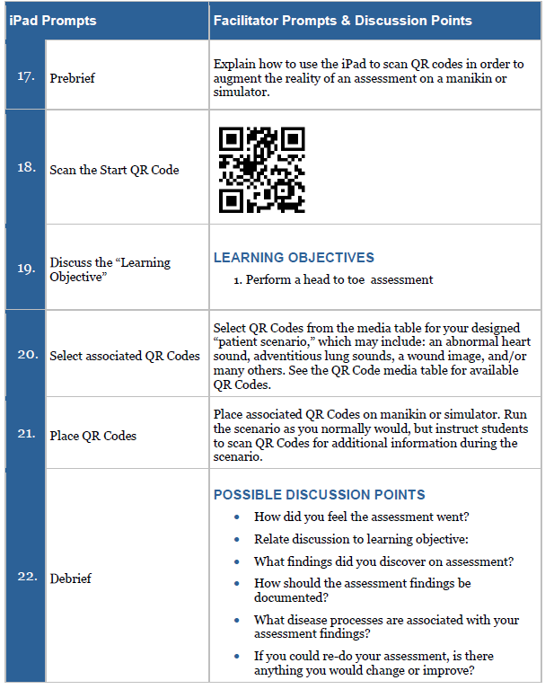

HEAD TO TOE ASSESSMENT | LEVEL: 1

 |  | - Take away: What have you learned from this activity that you will take to your clinical practice?
 | End Scenario | - Students can exit at any time by tapping the Exit tab and following instructions.  - Please have each student complete the provided survey.

HEAD TO TOE ASSESSMENT | LEVEL: 1

HEAD TO TOE ASSESSMENT | LEVEL: 1
CREDITS

Coughing sounds from Soundbible. Downloaded from http://soundbible.com/tags-cough.html

Croup coughing sounds from Amit Kumar Patel. Downloaded from https://www.youtube.com/watch?v=f9RlrdJTsa8

Heart and Lungs sounds from Thinklabs with permission. Downloaded from https://www.thinklabs.com/

Pressure ulcer images purchased from National Pressure Ulcer Advisory Panel Online Store.
Available at: https://www.npuap.org/online-store/

Multiple images and sounds from Wikimedia. Downloaded from https://commons.wikimedia.org Multiple images and sounds from Wikipedia. Downloaded from https://en.wikipedia.org/
Neonatal grunting lung sound is used with permission from R.A.L.E. repository. Copyright © 2013, by Medi-Wave Inc. All rights reserved. For more information please visit http://www.RALE.ca

Pressure ulcer images purchased from National Pressure Ulcer Advisory Panel Online Store.
Available at: https://www.npuap.org/online-store/

Some patient videos purchased from Shutterstock

Suture image from Pixabay. Downloaded from https://pixabay.com/p-103061/?no_redirect
HEAD TO TOE ASSESSMENT | LEVEL: 1
REFERENCES

Campbell EW JR, Lynn CK. The Physical Examination. In: Walker HK, Hall WD, Hurst JW, editors. Clinical Methods: The History, Physical, and Laboratory Examinations. 3rd edition. Boston: Butterworths; 1990. Chapter 4. Available from: https://www.ncbi.nlm.nih.gov/books/NBK361/
Dreifuerst, Kristina Thomas (2012). Using debriefing for meaningful learning to foster development of clinical reasoning in simulation. Journal of Nursing Education, 51(6), 326-333. doi:http://dx.doi.org/10.3928/01484834-20120409-02
Henley Haugh, K. (2015). Head-to-toe: Organizing your baseline patient physical assessment.
Nursing, 45(12), 58. doi:10.1097/01.NURSE.0000473396.43930.9d
International Nursing Association for Clinical Simulation and Learning (2016). Standards of Practice: Simulation. Downloaded from http://www.inacsl.org/i4a/pages/index.cfm?pageid=3407
This work by the Wisconsin Technical College System TAACCCT IV Consortium is licensed under a Creative Commons Attribution 4.0 International license.
Third party marks and brands are the property of their respective holders. Please respect the copyright and terms of use on any webpage links that may be included in this document.
This workforce product was funded by a grant awarded by the U.S. Department of Labor’s Employment and Training Administration. The product was created by the grantee and does not necessarily reflect the official position of the U.S. Department of Labor. The U.S. Department of Labor makes no guarantees, warranties, or assurances of any kind, express or implied, with respect to such information, including any information on linked sites and including, but not limited to, accuracy of the information or its completeness, timeliness, usefulness, adequacy, continued availability, or ownership. This is an equal opportunity program. Assistive technologies are available upon request and include Voice/TTY (771 or 800-947-6644).c

