Equipment Check List
Course #: Course Name: Scenario:
Patient Name: ID Number: Date of Birth:
On | Avail |  | On | Avail |  | On | Avail
 |  | Mannequin |  |  | Body Fluids |  |  | Confederates:
 |  | HAL |  |  | Sweat |  |  | Name badges
 |  | Noelle |  |  | Emesis |  |  | Wardrobe
 |  | NB HAL |  |  | Basin Chux |  |  | Other
 |  | Hal 1 |  |  | Qual
 |  | HAL 5 |  |  | Quan ml
 |  | 3G |  |  | Urine
 |  | SimMan Classic |  |  | Foley Urinal |  |  | Mannequin Status
 |  | SimBaby |  |  | Qual |  |  | Male Female
 |  | Megacode Kelly |  |  | Quan ml |  |  | Position:
 |  | Megacode Kid |  |  | Feces |  |  | ID bracelet
 |  | Other |  |  | Bag Chux |  |  | Allergy:
 |  | Standardized Pt |  |  | Qual |  |  | Gown
 |  | Monitor |  |  | Quan ml |  |  | Clothes
 |  | EKG |  |  | Blood |  |  | Upper:
 |  | Pulse ox |  |  | Other |  |  | Lower:
 |  | NIBP |  |  |  |  |  | Feet:
 |  | Temp |  |  |  |  |  | Wig:
 |  | Arterial Line |  |  |  |  |  | Hat:
 |  | Central Line |  |  | Equipment, Tubes |  |  | Glasses:
 |  | FloTrac PA Cath |  |  | NG tube |  |  | Dressings:
 |  | Ventric |  |  | OG tube
 |  | Other |  |  | Foley catheter
 |  |  |  |  | Rectal tube
 |  |  |  |  | Gastric lavage |  |  | Moulage:
 |  | Oxygen |  |  | PEG / Fdg tube
 |  | None |  |  | Epidural catheter
 |  | Nasal cannula@ |  |  | Chest tube | 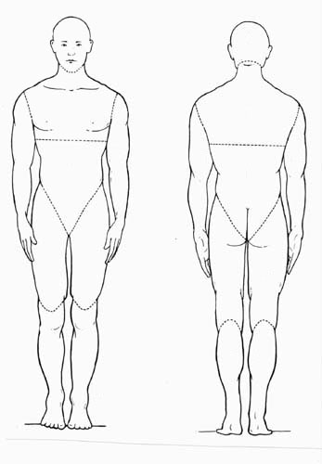
 |  | NRB Mask @ % |  |  | Other
 |  | Venturi @ %
 |  | BiPAP
 |  | Intubated |  |  | Equipment, Other
 |  | Trach |  |  | Glucometer
 |  | Vent: Mode: Rate FiO₂ PEEP |  |  | iSTAT
 |  | Vent: Mode: Rate FiO₂ PEEP |  |  | Cervical Collar
 |  | Other: |  |  | Backboard
 |  |  |  |  | Emesis basin
 |  |  |  |  | Hare traction
 |  |  |  |  | Dishes
 |  | Intubation Equip. |  |  | Other
 |  | ETT sizes - |  |  | Mouth swab
 |  | Blades -
 |  | Handle |  |  | Procedures
 |  | ET introducer/Bougie |  |  | Needle thoracostomy
 |  | Suction |  |  | Chest Tube
 |  | BVM |  |  | Pericardiocentesis
 |  | OPA NPA |  |  | LP
 |  | ETCO2 detector |  |  | Central line
 |  | Bulb detection device |  |  | Other

