SKILL FOCUS: Heart Sound Interpretation DISCIPLINE: Multidiscipline LEVEL: 1
HEART SOUNDS INTERPRETATION | LEVEL: 1

HEART SOUNDS INTERPRETATION

Estimated Time: 15 minutes
Instructor Handout

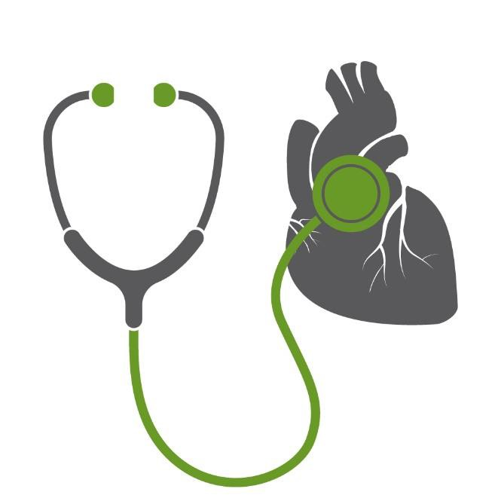Scan to Begin

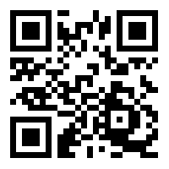

SERIOUS GAME OVERVIEW

In this serious game, students are tasked with interpreting the following heart sounds:

- Normal Newborn
- S3
- S4
- Atrial Fibrillation
- Murmur

INSTRUCTIONS

- Present students with the printed Heart Sound Interpretation Serious Game
student handout.
- Using the ARIS app on an iPad, students scan the provided QR Code to begin each game.
- For each heart sound, students are shown a patient video which sets the context of the scenario. Then, a heart sound is provide. Students are required to identify the heart

HEART SOUNDS INTERPRETATION | LEVEL: 1
sound, a potential cause of the sound, and select an appropriate medication that could potentially be used to treat the patient with the heart sound.
- A Rationale is provided after each question to enhance student knowledge related to the heart sound.
- At the end of the game, stars are displayed based on how many correct answers the student achieved. A screen shot of this image with the timestamp provided can be taken and submitted to the instructor for proof of completion. No two timestamps will be the same.

LEARNING OBJECTIVES

- Accurately identify various types of heart sounds.
- Identify potential causes of different types of heart sounds.
- Plan appropriate interventions for different types of heart sounds.

SCORING

- Throughout each serious game, students earn “stars” for correct answers. Their goal is to
collect all of the possible stars and become a “Star Heart Sound Interpreter.”
HEART SOUNDS INTERPRETATION | LEVEL: 1
- At the end of each game, a “Star Score” screen is displayed on the iPad which shows both the number of stars earned and a statement stating how well they did. Scores and statements correspond to the following table:

Total Stars Awarded | Accompanied iPad Language
100% | Outstanding! You identified all of the heart sounds and appropriate interventions correctly. Keep up the great work!
99-93% | Great job! You answered most of the questions about heart sounds and corresponding interventions correctly.
92-85% | You did well, but we think you can do even better. Try your heart sound assessments and interventions again
84-80% | Not bad, but your heart sound identification and interventions still need some work. Try your heart sound assessments and interventions again
79% or lower | Try again! We know you can do better next time at identifying heart sounds and appropriate interventions

- As an option, a timestamp is also provided on the final “Star Score” screen. Students can take a screen shot of this and email it to their instructor as “evidence” that they completed this serious game successfully.

HEART SOUNDS INTERPRETATION | LEVEL: 1
CREDITS

Heart sounds used from Heart Sounds Library at Thinklabs with permission. Downloaded from https://www.thinklabs.com/heart-sounds

REFERENCES

Gersh, B. (2017). Auscultation of heart sounds. In: UptoDate, Otto, C. (Ed), UptoDate, Waltham, MA. (Accessed on January 26, 2018)

Kumar, K. (2017). Overview of atrial fibrillation. In: UptoDate, Saperia, G. (Ed), UptoDate, Waltham, MA. (Accessed on January 26, 2018)

McKee-Garrett, T. (2017). Assessment of the newborn infant. In: UptoDate, Kim, M. (Ed), UptoDate, Waltham, MA. (Accessed on January 26, 2018)

Meyer, T. (2018). Auscultation of cardiac murmurs in adults. In: UptoDate, Yeon, S. (Ed), UptoDate, Waltham, MA. (Accessed on January 26, 2018)

National Heart, Lung and Blood Institute (2018). Heart Murmur. Accessed at: https://www.nhlbi.nih.gov/health-topics/heart-murmur

National Heart, Lung and Blood Institute (2018). Atrial fibrillation. Accessed at: https://www.nhlbi.nih.gov/health-topics/atrial-fibrillation

This work by the Wisconsin Technical College System TAACCCT IV Consortium is licensed under a Creative Commons Attribution 4.0 International license.
Third party marks and brands are the property of their respective holders. Please respect the copyright and terms of use on any webpage links that may be included in this document.
This workforce product was funded by a grant awarded by the U.S. Department of Labor’s Employment and Training Administration. The product was created by the grantee and does not necessarily reflect the official position of the U.S. Department of Labor. The U.S. Department of Labor makes no guarantees, warranties, or assurances of any kind, express or implied, with respect to such information, including any information on linked sites and including, but not limited to, accuracy of the information or its completeness, timeliness, usefulness, adequacy, continued availability, or ownership. This is an equal opportunity program. Assistive technologies are available upon request and include Voice/TTY (771 or 800 -947-6644).c

