S E R I O U S G A M E
SKILL FOCUS: OB Fetal Monitoring DISCIPLINE: Nursing LEVEL: 1
OB FETAL MONITORING | LEVEL: 1

OB FETAL MONITORING

Estimated Time: 15 minutes

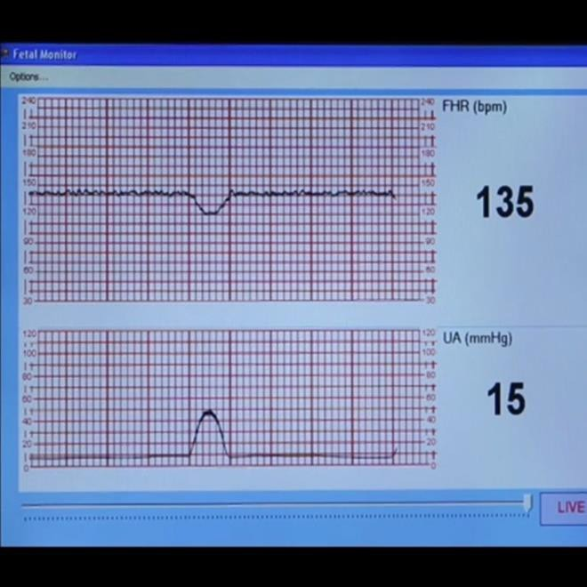Scan to Begin



SCENARIO OVERVIEW

In this serious game, students interpret four fetal monitoring strips and answer associated multiple choice questions. The purpose of this game is to practice interpreting fetal monitoring strips and select appropriate interventions, before caring for a patient in labor in simulation and/or clinical practice.
OB FETAL MONITORING | LEVEL: 1

LEARNING OBJECTIVES

- Correctly interpret fetal monitoring strips
- Select appropriate nursing care

INSTRUCTIONS

Scan the Start QR Code to begin the game. Stars are earned for each correct answer with a final score provided at the end of the game.

SCORING
- Throughout the game you will earn “stars” for correct answers.
The goal is to collect all of the possible stars and become a “Star Lung Sound Interpreter.”
- At the end of each game, a “Star Score” screen is displayed on the iPad
which shows both the number of stars earned and a statement stating how well you did.
Scores and statements correspond to the following table:
Total Stars Awarded | Accompanied iPad Language
100% | Outstanding! You identified all of the lung sounds and appropriate interventions correctly. Keep up the great work!
99-93% | Great job! You answered most of the questions about identifying lung sounds and corresponding interventions correctly.
92-85% | You did well, but we think you can do even better. Try your lung sound identification and interventions again.
84-80% | Not bad, but your lung sound identification skills and interventions still need some work. Try your lung sound identification and interventions again.
79% or lower | Try again! We know you can do better next time at identifying lung sounds and appropriate interventions.
A timestamp is also provided on the final “Star Score” screen.
Take a screen shot of the Star Score screen with the timestamp.
Be aware that NO two timestamps are the same.
Turn the Star Score screen shot in to your instructor as “evidence” that you
completed the game successfully.

OB FETAL MONITORING | LEVEL: 1

REFERENCES

Funai, E, and Norwitz, E (2017). Management of normal labor and delivery. In: UptoDate, Lockwood, C (Ed), UptoDate, Waltham, MA. (Accessed on July 26, 2017)

Sweha, A., and Hacker, TW. (1999) Interpretation of the electronic fetal heart rate during labor.
American Family Physician, 1; 59(9): 2487-500. Accessed at https://www.ncbi.nlm.nih.gov/pubmed/10323356?dopt=Abstract

This work by the Wisconsin Technical College System TAACCCT IV Consortium is licensed under a Creative Commons Attribution 4.0 International license.
Third party marks and brands are the property of their respective holders. Please respect the copyright and terms of use on any webpage links that may be included in this document.
This workforce product was funded by a grant awarded by the U.S. Department of Labor’s Employment and Training Administration. The product was created by the grantee and does not necessarily reflect the official position of the U.S. Department of Labor. The U.S. Department of Labor makes no guarantees, warranties, or assurances of any kind, express or implied, with respec t to such information, including any information on linked sites and including, but not limited to, accuracy of the information or its completeness, timeliness, usefulness, adequacy, continued availability, or ownership. This is an equal opportunity program. Assistive technologies are available upon request and include Voice/TTY (771 or 800-947-6644).c

