S E R I O U S G A M E
SKILL FOCUS: Assessing Wounds DISCIPLINE: Assessment LEVEL: 2

WOUND ASSESSMENT 2

Estimated Time: 15 minutes

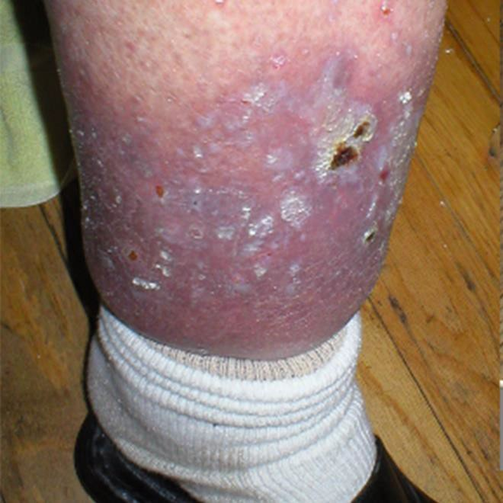Scan to Begin
WOUND ASSESSMENT | LEVEL: 2



SCENARIO OVERVIEW

In this serious game, various images of arterial ulcers, venous ulcers, diabetic ulcers, and pressure ulcers are provided for students to assess and identify appropriate interventions. The purpose of this game is for students to practice caring for a patient with wound before simulation and/or clinical practice.

LEARNING OBJECTIVES

- Accurately identify various types of wounds, including venous ulcers, arterial ulcers, diabetic ulcers and pressure ulcers.
- Identify potential causes of different types of wounds.
- Plan appropriate interventions for different types of wounds.

INSTRUCTIONS

Scan the Start QR Code to begin the game. Stars are earned for each correct answer with a final score provided at the end of the game.

SCORING
- Throughout the game you will earn “stars” for correct answers.
The goal is to collect all of the possible stars and become a “Star Lung Sound Interpreter.”
- At the end of each game, a “Star Score” screen is displayed on the iPad
which shows both the number of stars earned and a statement stating how well you did.
Scores and statements correspond to the following table:
Total Stars Awarded | Accompanied iPad Language
100% | Outstanding! You identified all of the lung sounds and appropriate interventions correctly. Keep up the great work!
99-93% | Great job! You answered most of the questions about identifying lung sounds and corresponding interventions correctly.
92-85% | You did well, but we think you can do even better. Try your lung sound identification and interventions again.
84-80% | Not bad, but your lung sound identification skills and interventions still need some work. Try your lung sound identification and interventions again.
79% or lower | Try again! We know you can do better next time at identifying lung sounds and appropriate interventions.
A timestamp is also provided on the final “Star Score” screen.
Take a screen shot of the Star Score screen with the timestamp.
Be aware that NO two timestamps are the same.
Turn the Star Score screen shot in to your instructor as “evidence” that you
completed the game successfully.

CREDITS

Images of wounds from Wikimedia. Downloaded from https://commons.wikimedia.org

Pressure ulcer images purchased from National Pressure Ulcer Advisory Panel Online Store.
Available at: https://www.npuap.org/online-store/

REFERENCES

Alguire, P., Mathes, B (2017). Medical management of lower extremity chronic venous disease In: UptoDate, Eidt, J. and Mils, J (Eds), UptoDate, Waltham, MA. (Accessed on December 12, 2017)
WOUND ASSESSMENT | LEVEL: 2

Armstrong, D. McCullouch, D., de Asla, R. (2017). Management of diabetic foot ulcers. In: UptoDate, Eidt, J., Mils, J and Nathan, D. (Eds), UptoDate, Waltham, MA. (Accessed on December 12, 2017)

Armstrong, D., and Meyr, A. (2017). Basic Principles of Wound Management. In: UptoDate, Sanfey, H., Eidt, J. Mils, J., and Bruera, E (Eds), UptoDate, Waltham, MA. (Accessed on December 12, 2017)

Armstrong, D., and Meyr, A. (2017) Compression therapy for the treatment of chronic venous insufficiency. In: UptoDate, Eidt, J. and Mils, J (Eds), UptoDate, Waltham, MA. (Accessed on December 12, 2017

National Pressure Ulcer Advisory Panel. NPUAP Pressure Ulcer Stages/Categories.
Downloaded from: http://www.npuap.org/wp-content/uploads/2012/01/NPUAP- Pressure-Ulcer-Stages-Categories.pdf

National Pressure Ulcer Advisory Panel (2014) Prevention and Treatment of Pressure Ulcers Clinical Practice Guidelines: Quick Reference Guide. Downloaded from:

https://www.npuap.org/resources/educational-and-clinical-resources/prevention-and- treatment-of-pressure-ulcers-clinical-practice-guideline/

Petersen, M (2016). Approach to the differential diagnosis of leg ulcers. In: UptoDate, Stratman, E.. and Ofori, A. (Ed), UptoDate, Waltham, MA. (Accessed on December 12, 2017)
WOUND ASSESSMENT | LEVEL: 2

This work by the Wisconsin Technical College System TAACCCT IV Consortium is licensed under a Creative Commons Attribution 4.0 International license.
Third party marks and brands are the property of their respective holders. Please respect the copyright and terms of use on any webpage links that may be included in this document.
This workforce product was funded by a grant awarded by the U.S. Department of Labor’s Employment and Training Administration. The product was created by the grantee and does not necessarily reflect the official position of the U.S. Department of Labor. The U.S. Department of Labor makes no guarantees, warranties, or assurances of any kind, express or implied, with respect to such information, including any information on linked sites and including, but not limited to, accuracy of the information or its completeness, timeliness, usefulness, adequacy, continued availability, or ownership. This is an equal opportunity program. Assistive technologies are available upon request and include Voice/TTY (771 or 800 -947-6644).c

